ADVANCED DATABASES PROJECT

MONGODB PROJECT - TOURIST



**Name: ADITYA CHANDRA**

**Student ID: A00268811**

**Course: M.Sc. in Data Analytics**

**Date of Submission: 9 May 2020**

Table of Contents

1. Project Overview 2

2. Database Setup, Collection Creation and Data Importation 3

3. MongoDB Shell – Simple Queries 5

4. MongoDB Shell – Aggregation Framework 29

5. MongoDB Compass Overview 42

6. MongoDB Compass – Simple Queries 44

7. MongoDB Compass – Aggregation Framework 48

8. MongoDB Atlas Overview 53

9. MongoDB Atlas – Simple Query 69

10. MongoDB Atlas – Aggregation Framework 70

11. MongoDB Compass and Atlas – Other Features Explored 71

11.1. Schema 71

11.2. Edit document 72

11.3. Activity History 73

12. Appendix 74

(a) Links to YouTube Screencasts 74

(b) Links to Referred Websites 74

# Project Overview

This MongoDB project deals with the records of tourists which includes informations like name, address, nationality, gender, birth year, status, telephone number, email address, special needs, payment method, interests, favourite destinations, expense breakdown, social media and twitter details.

Normal Fields

Tourist (_Id, FirstName, Lastname, Address, Nationality, Gender, Year_Born, Status (Retired, Working, Student, Career Break etc), Telephone_No, Email_Address, Special_Needs, Pay_Method)

Arrays

i) Interests – Array with one or more of (Music, Art Galleries, Museums, Architecture, Literature, History, Hiking, Walking, Cycling, Surfing, Swimming etc)

Could have some tourists with one set of interests (Music, Art Galleries, Museums, Architecture, Literature, History) and others with one or more sporting related interests (Hiking, Walking, Cycling, Surfing, Swimming etc) – so you could populate the array from two different lists of values.

ii) Favourite_Destinations – Array with a list of countries or an Array with a list of popular tourist attractions – e.g. Eiffel Tower, Cliffs of Moher etc

Embedded Documents

Spending - need to capture the amount of money the tourist spends on while travelling Spending.Travel, Spending.Accommodation, Spending.Food

Social_Media – details (names/ urls) of the various social media accounts held by the tourist - Social_Media – Social_Media.Facebook, Social_Media.Instagram

Twitter – twitter details for the tourist – Twitter.Account (twitter username). Twitter.Num_Following, Twitter.Num_Followers

We will explore the use of queries in MongoDB shell, MongoDB Compass and MongoDB Atlas to perform CRUD (Create, Read, Update and Delete) operations on the data with the help of simple queries and aggregation framework queries. We will also look into the process of database and collection creation and importation of data using these three tools.

# Database Setup, Collection Creation and Data Importation

The data for tourists is stored in a JSON file named Msc2020_Tourist_A_Chandra.json. To explore MongoDB functionalities in the *Shell*, we will create a database named *MSC_DA* inside which we will create a collection named *Tourist* where the data will be stored. We can use the *mongoimport* command to load the data through MongoDB Shell.

The command to load the data from the json is:

mongoimport -d MSC_DA -c Tourist --file C:\datafiles\Msc2020_Tourist_A_Chandra.json --jsonArray

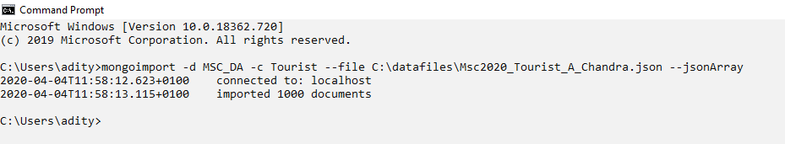

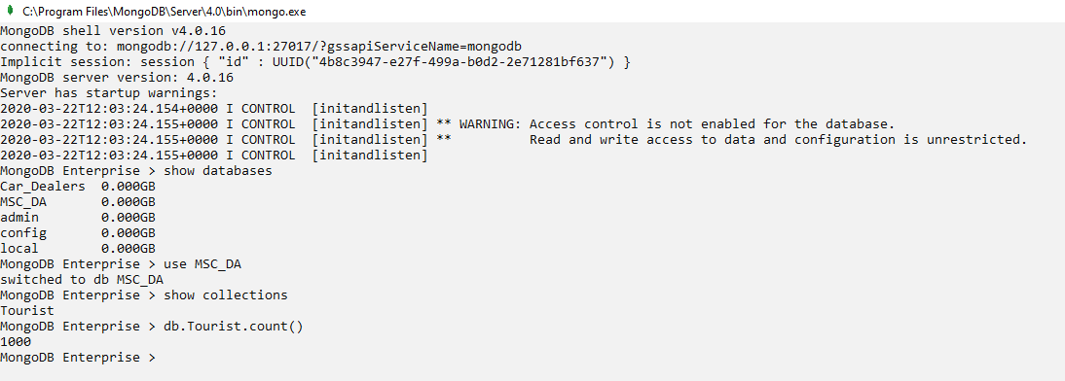

The screenshot of first two documents from the collection is shown below to take a look at all the fields in the documents and the type of data stored in them.

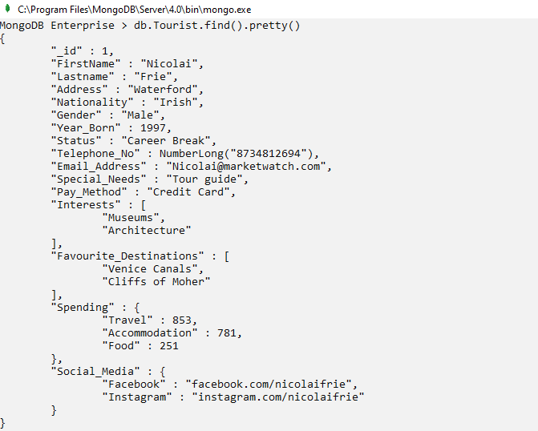

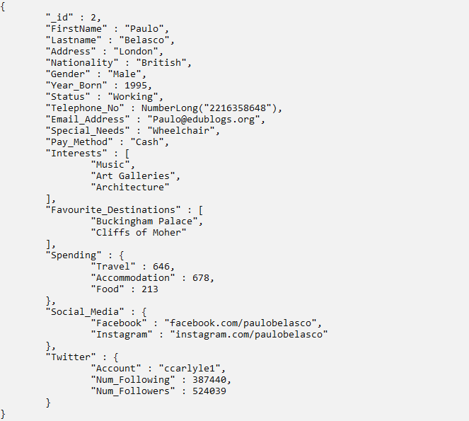

# MongoDB Shell – Simple Queries

1. **Display the firstname, lastname, address, nationality and year of birth of those tourists whose address is London.**

db.Tourist.find({Address: "London"},

{_id:0, FirstName:1, Lastname:1, Address:1, Nationality:1, Year_Born:1})

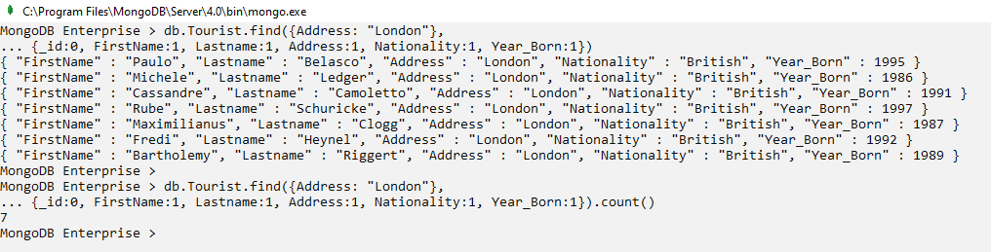

1. **Display details of those tourists whose address is Dublin and are born after the year 2000.**

db.Tourist.find(

{"Address":"Dublin",

"Year_Born": {$gt:2000}}

).pretty()

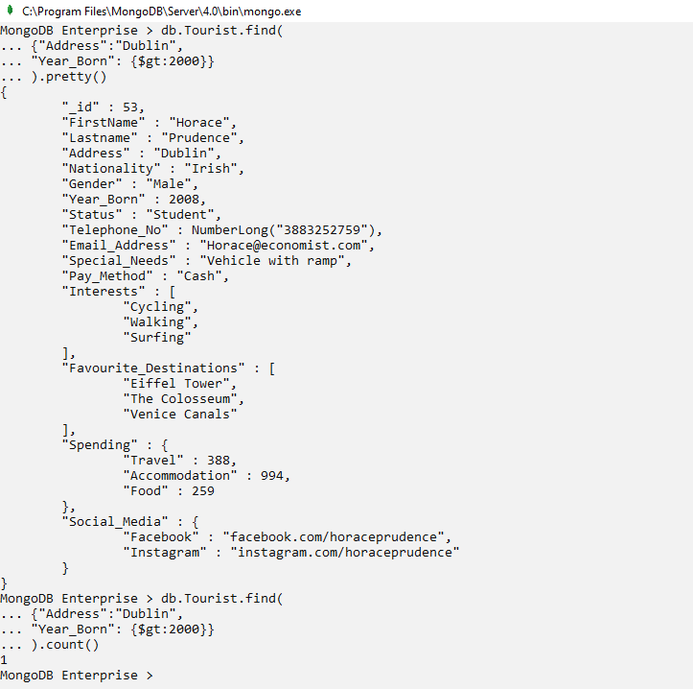

1. **Display firstname, lastname and special needs of those tourists who are interested in only museums and literature (in the given order).**

db.Tourist.find(

{"Interests": ["Museums","Literature"]},

{"_id": 0, "FirstName":1, "Lastname":1, "Special_Needs":1, *"Interests":1*}

)

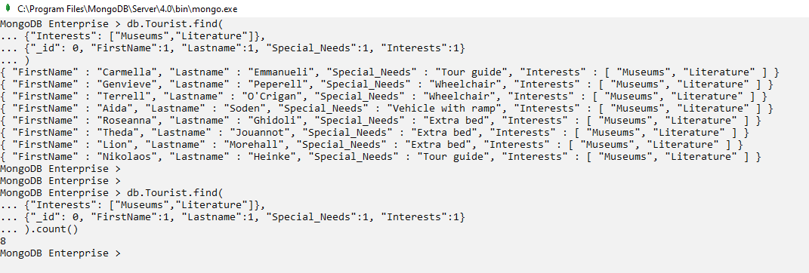

1. **Display the lastname, address, status and favourite destinations of those tourists whose status is career break and whose favourite destinations are The Colosseum and Venice Canals (in the given order).**

db.Tourist.find(

{"Status": "Career Break",

"Favourite_Destinations": ["The Colosseum", "Venice Canals"]},

{"_id":0, "Lastname":1, "Address":1, "Status":1, "Favourite_Destinations":1}

)

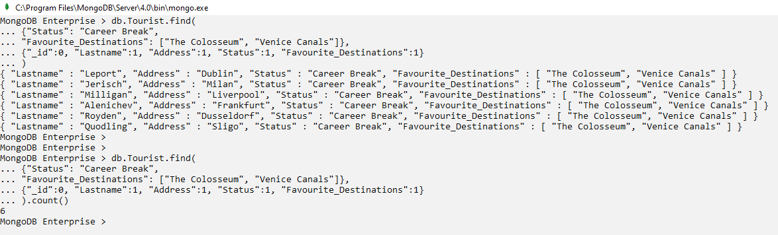

1. **Display the firstname, lastname, nationality, gender, pay method, interests and special needs of male French tourists who need tour guide and have interest in at least hiking and cycling.**

db.Tourist.find(

{"Nationality":"French",

"Gender":"Male",

"Special_Needs":"Tour guide",

"Interests": {$all:["Hiking","Cycling"]}},

{"_id":0, "FirstName":1, "Lastname":1, "Nationality":1, "Gender":1, "Pay_Method":1, "Interests":1, "Special_Needs":1}

).pretty()

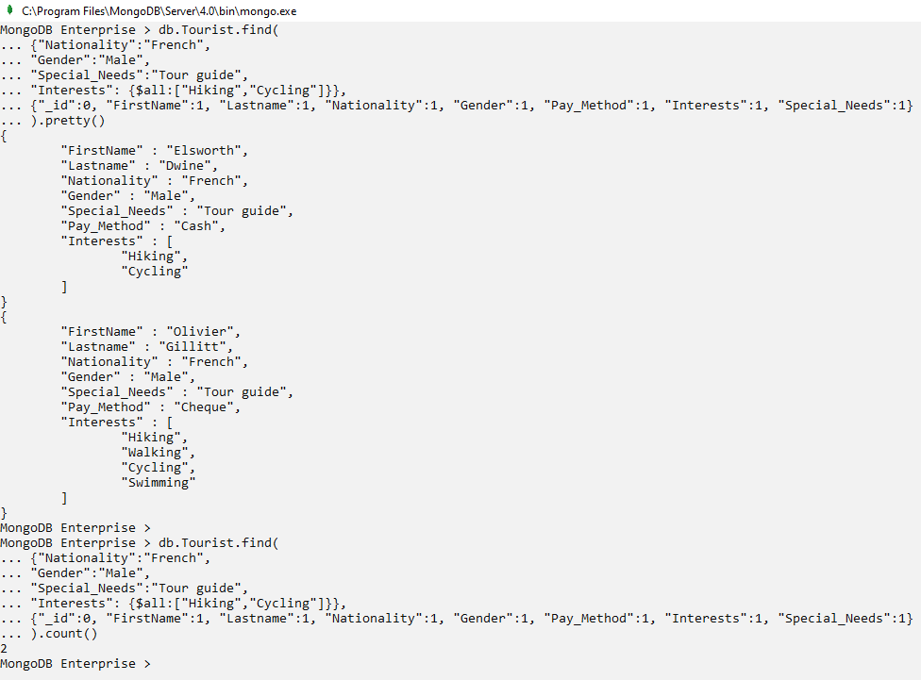

1. **Display the firstname, lastname, address, status, gender and payment method of those tourists who are from Liverpool and whose status is neither working nor student.**

db.Tourist.find(

{"Address":"Liverpool",

"Status":{$nin: ["Working","Student"]}},

{_id:0, FirstName:1, Lastname:1, Address:1, Status:1, Gender:1, Pay_Method:1})

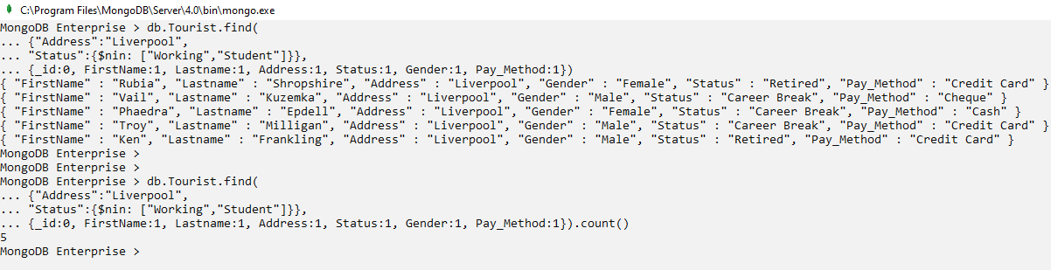

1. **Display firstname, birth year, status and spending of those tourists who were not born after 2005 and spend at least 700 euros on travel, more than 500 euros on accommodation and no more than 200 euros on food.**

db.Tourist.find(

{"Year_Born":{$lte:2005},

"Spending.Travel":{$gte:700},

"Spending.Accommodation":{$gt:500},

"Spending.Food":{$lt:200}},

{"_id":0, "FirstName":1, "Year_Born":1, "Status":1, "Spending.Travel":1, "Spending.Accommodation":1, "Spending.Food":1}

)

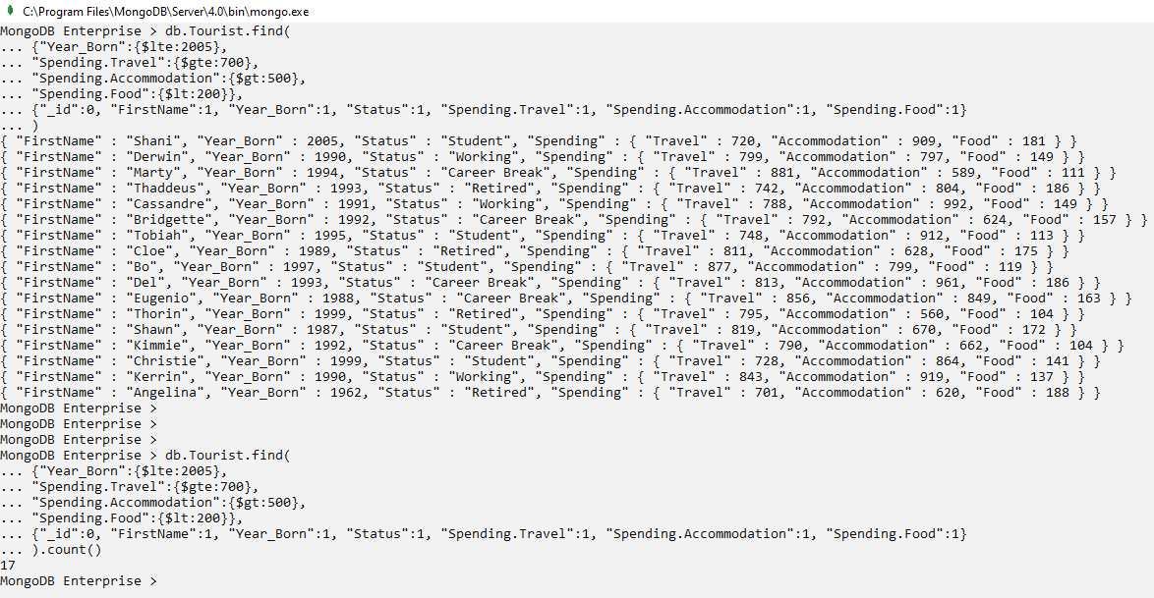

1. **Display all the details for those customers who use no social media and Twitter.**

db.Tourist.find(

{"Social_Media":null,

"Twitter":null}

).pretty()

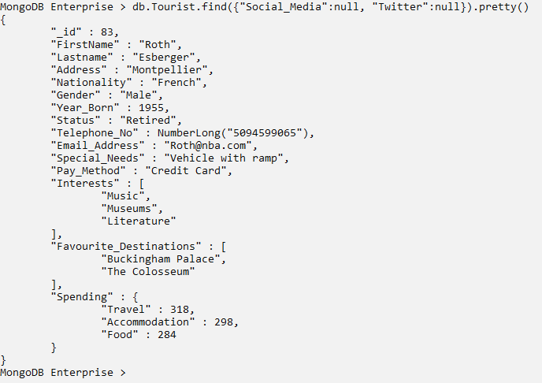

1. **Display the lastname, gender, email address and pay method of those tourists who use Facebook but do not use Instagram.**

db.Tourist.find(

{"Social_Media.Facebook":{$exists:true},

"Social_Media.Instagram":null},

{"_id":0, "Lastname":1, "Gender":1, "Email_Address":1, "Pay_Method":1, "Social_Media":1}

)

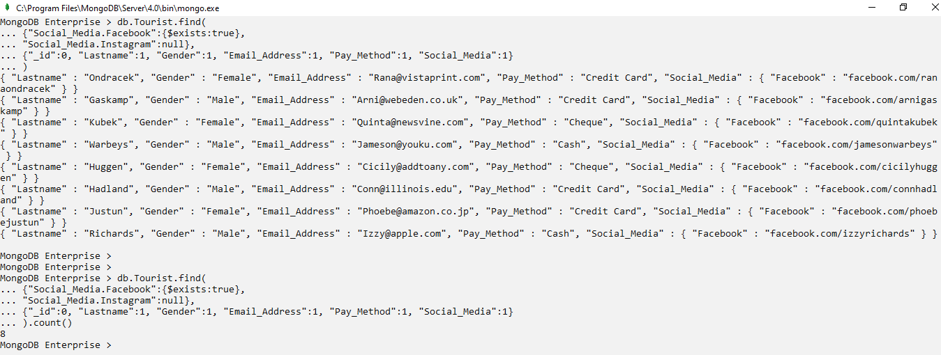

1. **Display the firstname, lastname, interests, favourite destinations, twitter’s number of following and twitter’s number of followers of those tourists who are interested in surfing and swimming and whose number of twitter followers lie between 900000 and 950000.**

db.Tourist.find(

{$and:[{"Interests": ["Surfing", "Swimming"]}, {"Twitter.Num_Followers":{$gte:900000}}, {"Twitter.Num_Followers":{$lt:1000000}}]},

{"_id":0, "FirstName":1, "Lastname":1, "Interests":1, "Favourite_Destinations":1, "Twitter":1}

).pretty()

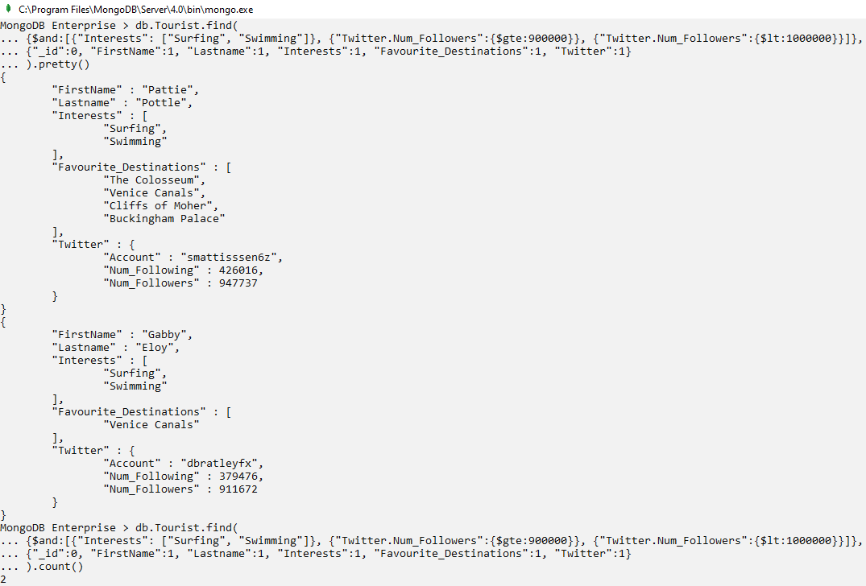

1. **Display the lastname, nationality, favourite destinations and spendings for those tourists whose nationality is not American, whose favourite destinations does not include The Colosseum, Venice Canals and Eiffel Tower; and who spend more than 800 euros on accommodation.**

db.Tourist.find(

{"Nationality": {$ne:"American"},

"Favourite_Destinations": {$nin:["The Colosseum","Venice Canals","Eiffel Tower"]}, "Spending.Accommodation": {$gte:800}},

{"_id":0, "Lastname":1, "Nationality":1, "Favourite_Destinations":1, "Spending.Accommodation":1}

)

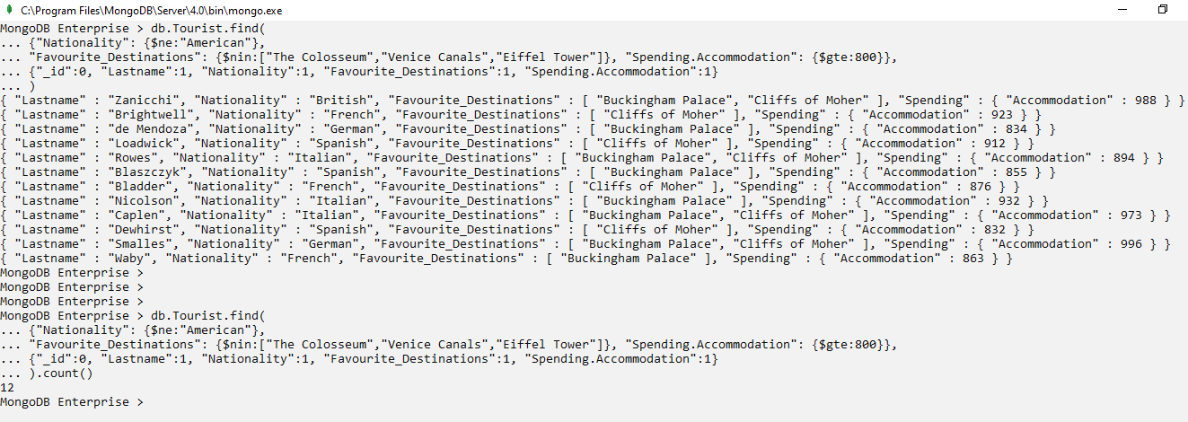

1. **Display the id, address, status, pay method, spending on travel and food for those tourists whose address do not start with letter L , who do not have a twitter account and who do not spend more than 250 euros on travel and food each.**

db.Tourist.find(

{"Address":{$not: {$regex: /^L.*/}},

"Twitter":{$exists:false},

$nor:[{"Spending.Travel":{$gt:250}},{"Spending.Food":{$gt:250}}]},

{"Address":1, "Status":1, "Pay_Method":1, "Spending.Travel":1, "Spending.Food":1}

)

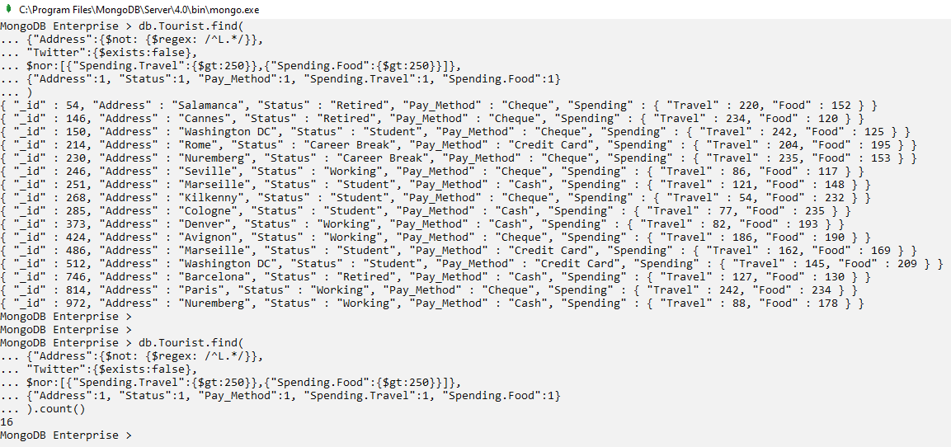

1. **Display the lastname, nationality, telephone number, interests and number of following on twitter for those tourists whose nationality starts with letter A, have exactly 4 interests and have less than 500000 number of followings on twitter.**

db.Tourist.find(

{"Nationality":{$regex: /^A.*/},

"Interests":{$size:4},

"Twitter.Num_Following": {$lt:500000}},

{"_id":0, "Lastname":1, "Nationality":1, "Telephone_No":1, "Interests":1, "Twitter.Num_Following":1}

)

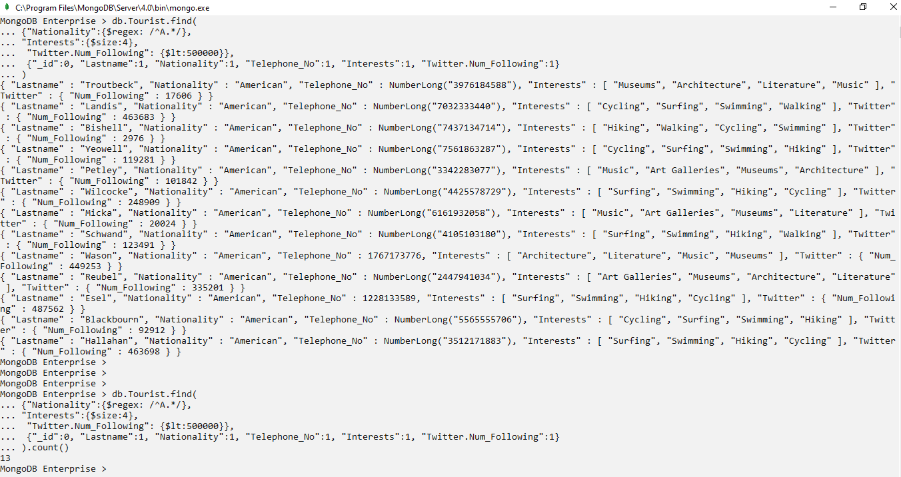

1. **Display the id, lastname, gender, pay method, amount spent on food and favourite destinations for those tourists whose last name end with letter ‘ke’, spend outside 200 and 500 euros on food and do not have 4 favourite destinations.**

db.Tourist.find(

{"Lastname":{$regex: /ke$/},

$or:[{"Spending.Food":{$lt:200}},{"Spending.Food":{$gt:500}}], "Favourite_Destinations":{$not:{$size:4}}},

{"Lastname":1, "Gender":1, "Pay_Method":1, "Spending.Food":1, "Favourite_Destinations":1}

)

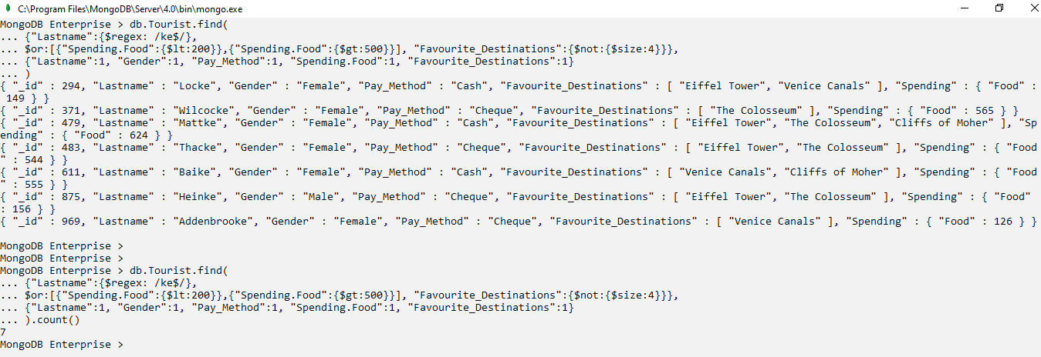

1. **Display the first name, gender, email address and interests of those female tourists who have less than 3 interests and their interest starts with letter H. The interests must include at least one of hiking, swimming or surfing.**

db.Tourist.find(

{$where: "this.Interests.length < 3",

"Interests":{$in:["Hiking","Swimming","Surfing"]},

"Interests":{$regex:/^H.*/},

"Gender":"Female"},

{"_id":0, "FirstName":1, "Gender":1, "Email_Address":1, "Interests":1}

)

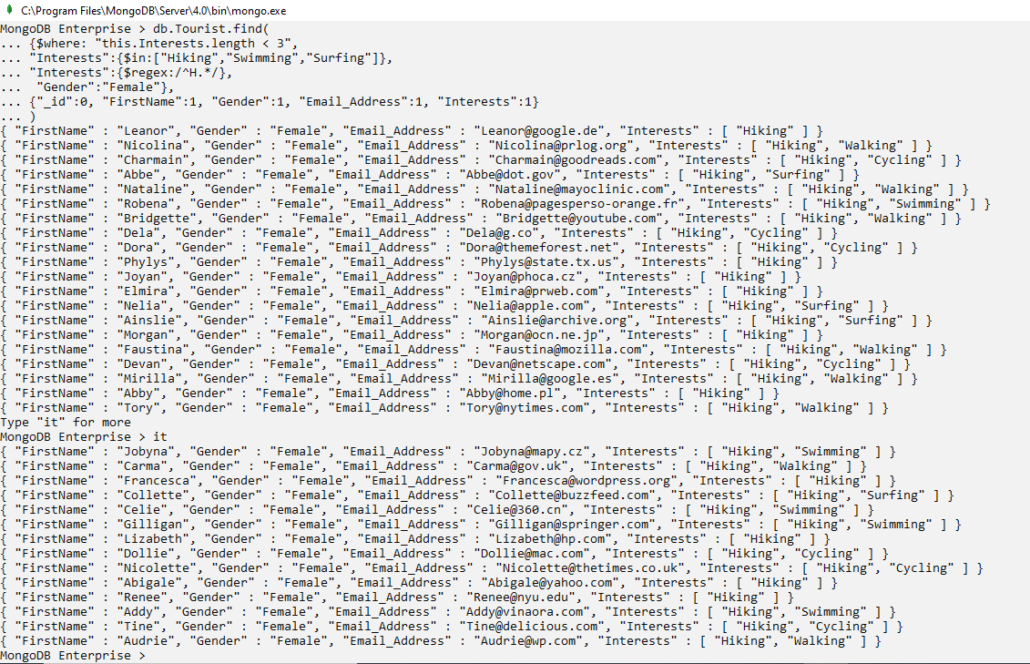

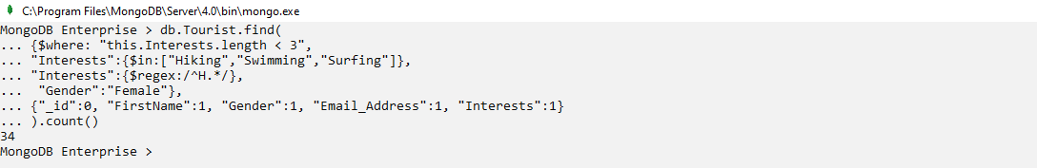

1. **Display all the details for those tourists who have a twitter account and have less or equal number of following than number of followers. The tourists should not have any social media account.**

db.Tourist.find(

{"Twitter":{$exists:true},

$expr: {$lte:["$Twitter.Num_Following","$Twitter.Num_Followers"]},

"Social_Media":null}

).pretty()

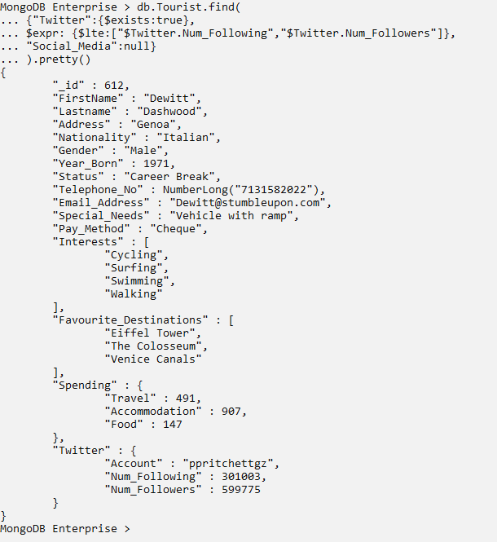

1. **Display the lastname, address, nationality and number of followers on twitter of those tourists whose number of followers on twitter are a multiple of 10 and whose nationality is Irish.**

db.Tourist.find(

{"Twitter.Num_Followers": {$mod:[10,0]},

"Nationality":"Irish"},

{"_id":0, "FirstName":1, "Lastname":1, "Address":1, "Nationality":1, "Twitter.Num_Followers":1}

)

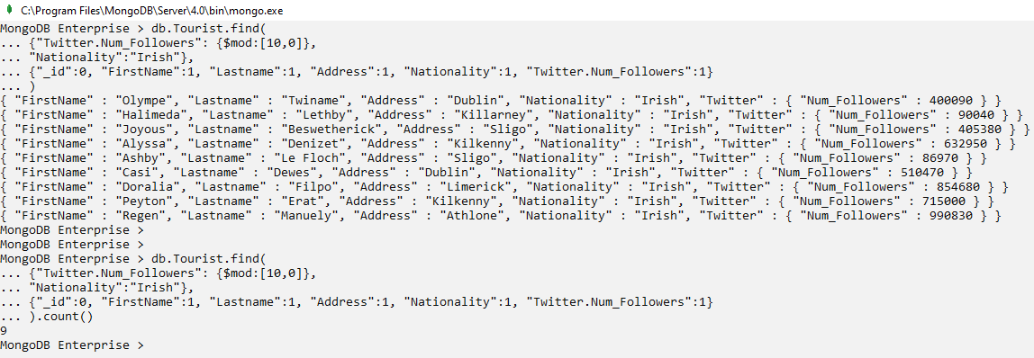

1. **Display the firstname, address, nationality, birth year, status, special needs and spendings of those tourists who do not have a twitter account, whose expenditure on food is greater than expenditure on accommodation and who are born in the year 2005,2006 or 2007. Arrange the results in ascending order of nationality.**

db.Tourist.find(

{"Twitter":{$exists:false},

$expr: {$gt:["$Spending.Food","$Spending.Accommodation"]}, "Year_Born":{$in:[2005,2006,2007]}},

{"_id":0, "FirstName":1, "Address":1, "Nationality":1, "Year_Born":1, "Status":1, "Special_Needs":1, "Spending":1, "Twitter":1}).sort({"Nationality":1}

).pretty()

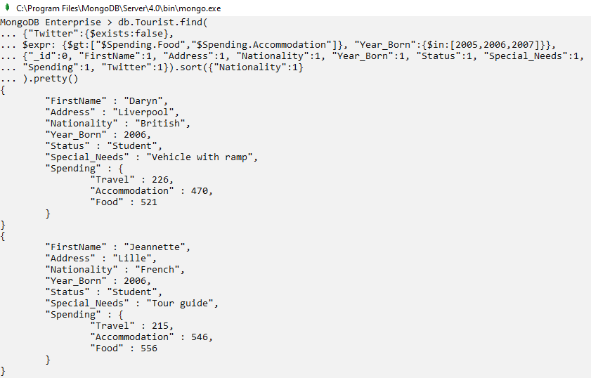

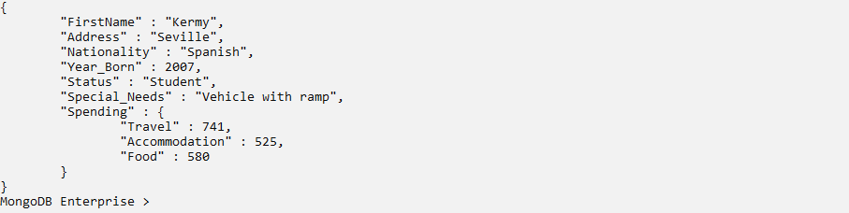

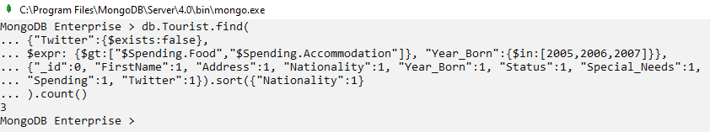

1. **Insert a document into the collection with details of one tourist.**

db.Tourist.insertOne(

{"_id":1001,

"FirstName":"Brendon",

"Lastname":"Tyler",

"Address":"Frankfurt",

"Nationality":"German",

"Gender":"Male",

"Year_Born":"1997",

"Status":"Working",

"Telephone_No":9088765237,

"Email":"brentyler@gmail.com",

"Special_Needs":"Tour guide",

"Pay_Method":"Credit Card",

"Interests":["Music","Architecture","Literature"],

"Favourite_Destinations":["Eiffel Tower","The Colosseum"],

"Spending":{

"Travel":860,

"Accommodation":920,

"Food":700},

"Social_Media":{

"Facebook":"facebook.com/brendontyler",

"Instagram":"instagram.com/brendontyler"},

"Twitter":{

"Num_Following":276800,

"Num_Followers":228650}

}

)

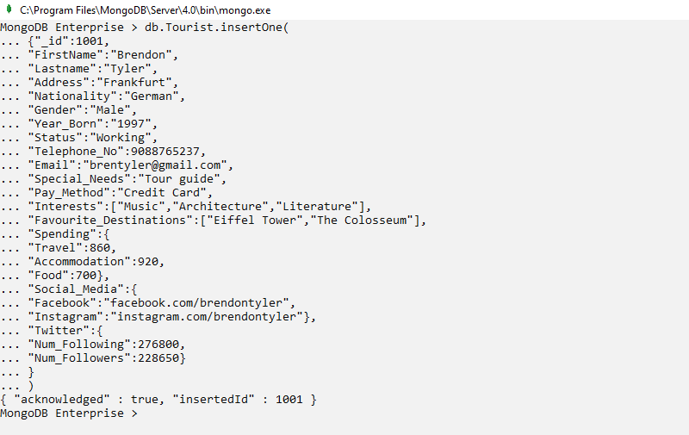

1. **Insert 3 documents at once into the collection with details of all the 3 tourists.**

db.Tourist.insertMany([

{"_id":1002,

"FirstName":"Aaron",

"Lastname":"William",

"Address":"Boston",

"Nationality":"American",

"Gender":"Male",

"Year_Born":2002,

"Status":"Student",

"Telephone_No":8738900214,

"Email":"aaronwilliam@hotmail.com",

"Special_Needs":"Vehicle with ramp",

"Pay_Method":"Cash",

"Interests":["Cycling","Surfing"],

"Favourite_Destinations":["Venice Canals", "Cliffs of Moher"],

"Spending":{

"Travel":540,

"Accommodation":380,

"Food":720},

"Social_Media":{

"Facebook":"facebook.com/aaronwill",

"Instagram":"instagram.com/aaronwill"},

"Twitter":{

"Num_Following":768906,

"Num_Followers":786522}

},

{"_id":1003,

"FirstName":"Susan",

"Lastname":"Richards",

"Address":"Athlone",

"Nationality":"Irish",

"Gender":"Female",

"Year_Born":2000,

"Status":"Student",

"Telephone_No":8765909041,

"Email":"susanrichards@hotmail.com",

"Special_Needs":"Wheelchair",

"Pay_Method":"Cheque",

"Interests":["Museums","Art Galleries","Literature"],

"Favourite_Destinations":["Buckingham Palace", "Cliffs of Moher", "The Colosseum"],

"Spending":{

"Travel":665,

"Accommodation":800,

"Food":980},

"Twitter":{

"Num_Following":366879,

"Num_Followers":498737}

},

{"_id":1004,

"FirstName":"Miriam",

"Lastname":"O'Keefe",

"Address":"Cardiff",

"Nationality":"British",

"Gender":"Male",

"Year_Born":1974,

"Status":"Retired",

"Telephone_No":8655976511,

"Email":"aaronwilliam@hotmail.com",

"Special_Needs":"Vehicle with ramp",

"Pay_Method":"Cheque",

"Interests":["Music","Literature"],

"Favourite_Destinations":["Buckingham Palace"],

"Spending":{

"Travel":660,

"Accommodation":770,

"Food":645}

}

])

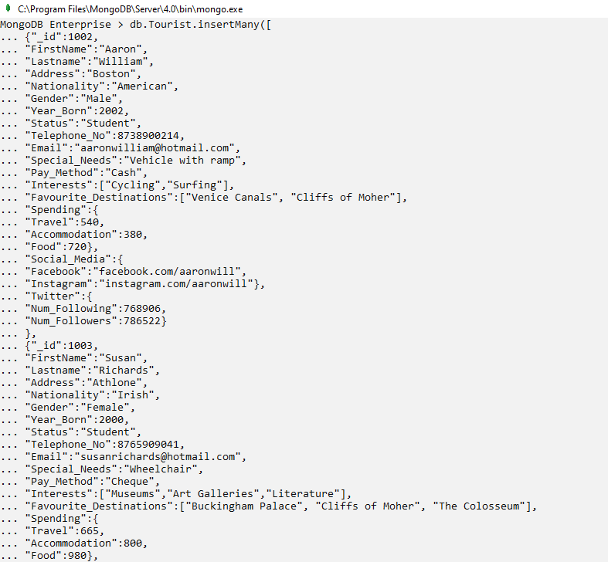

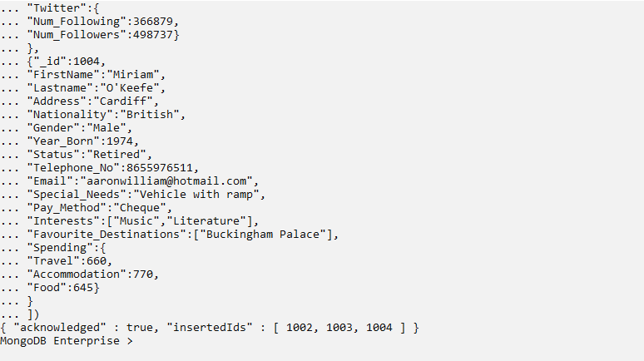

1. **Display the details of those tourists whose year born field have string values.**

db.Tourist.find(

{"Year_Born":{$type:"string"}}

).pretty()

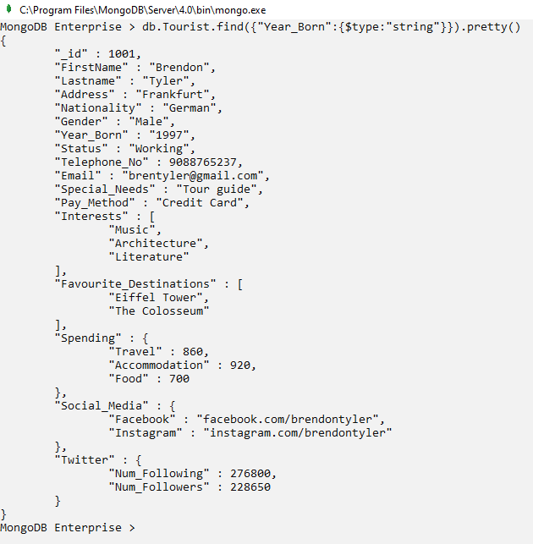

1. **Update the year born to number for the tourists whose birth year is of type string to equivalent number.**

db.Tourist.update(

{"Year_Born":{$type:"string"}},

{$set: {"Year_Born":1997}}

)

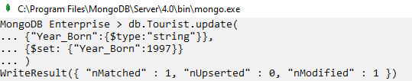

db.Tourist.find({"Year_Born":{$type:"string"}}).count()



1. **For the tourist named Miriam O’Keefe update the gender to female and special needs to wheelchair.**

db.Tourist.update(

{"FirstName":"Miriam", "Lastname":"O'Keefe"},

{$set: {"Gender":"Female", "Special_Needs":"Wheelchair"}}

)

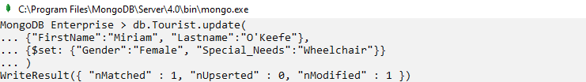

db.Tourist.find({"FirstName":"Miriam", "Lastname":"O'Keefe"}).pretty()

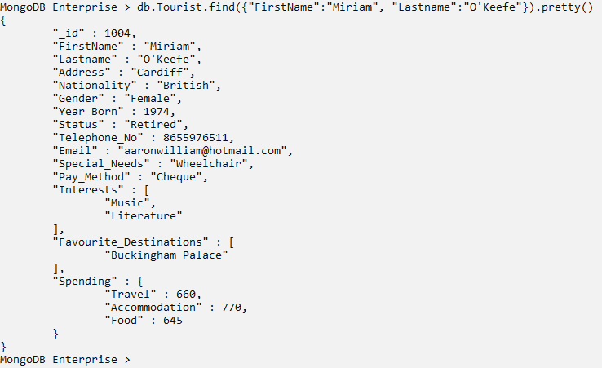

1. **For the newly inserted documents (id: 1001,1002,1003,1004) create a new field called ‘newdoc’ and set it to true.**

db.Tourist.updateMany(

{"_id":{$in:[1001,1002,1003,1004]}},

{$set: {"newdoc":true}},

{upsert: true}

)

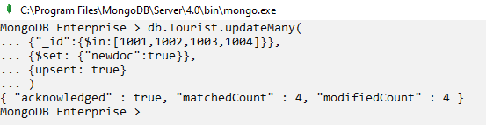

db.Tourist.find(

{"_id":{$in:[1001,1002,1003,1004]}},

{"FirstName":1,"Lastname":1,"newdoc":1}

)

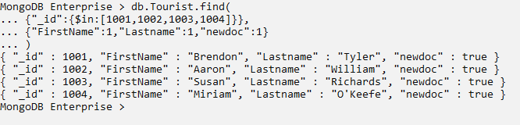

1. **Rename the newly added field ‘newdoc’ to ‘NewField’.**

db.Tourist.updateMany(

{"newdoc":true},

{$rename: {"newdoc":"NewField"}}

)

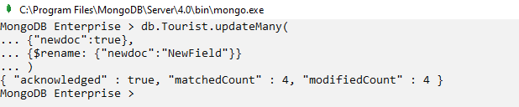

db.Tourist.find(

{"NewField":true},

{"FirstName":1,"Lastname":1,"NewField":1}

)

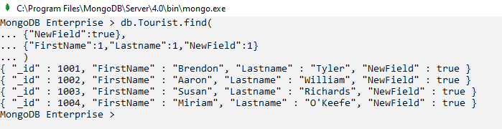

1. **For newly added tourists, increment the spending on accommodation by 20 and spending on food by 50.**

db.Tourist.updateMany(

{"NewField":true},

{$inc: {"Spending.Accommodation":20, "Spending.Food":50}}

)

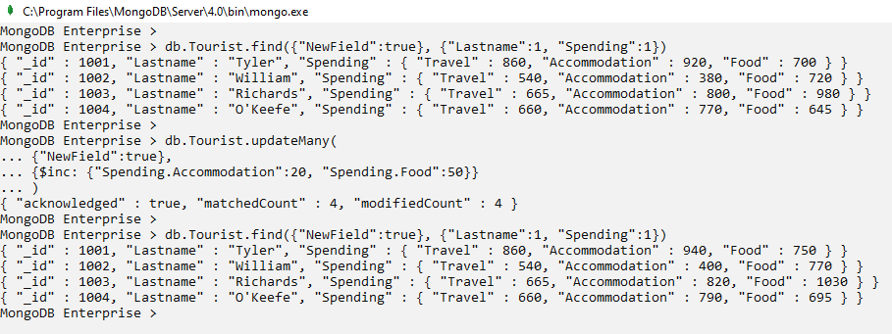

1. **For newly added tourists, compare their travel expense amount to 700 euros and update the value to maximum of the two.**

db.Tourist.updateMany(

{"NewField":true},

{$max:{"Spending.Travel":700}}

)

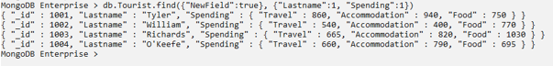

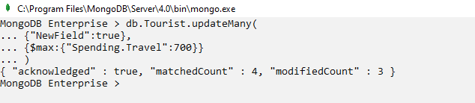

db.Tourist.find({"NewField":true}, {"Lastname":1, "Spending.Travel":1})

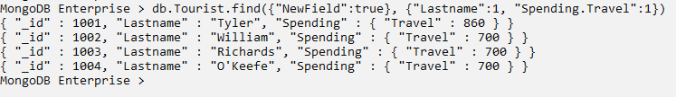

1. **For newly added tourists, compare their accommodation expense amount to 800 euros and update the value to minimum of the two.**

db.Tourist.updateMany(

{"NewField":true},

{$min:{"Spending.Accommodation":800}}

)

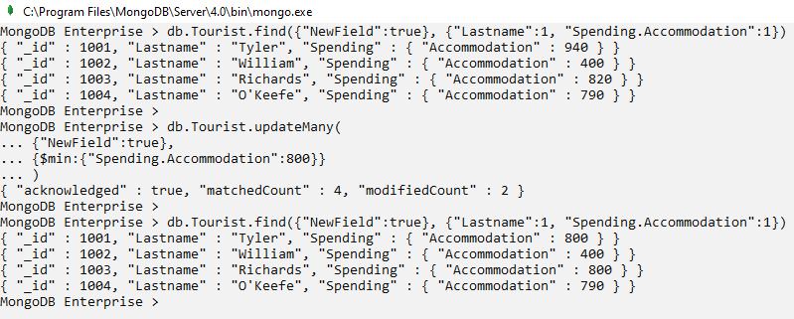

1. **For newly added tourists, reduce the spending on travel by half and increase the spending on food by 1.5 times.**

db.Tourist.updateMany(

{"NewField":true},

{$mul:{"Spending.Travel":0.5, "Spending.Food":1.5}}

)

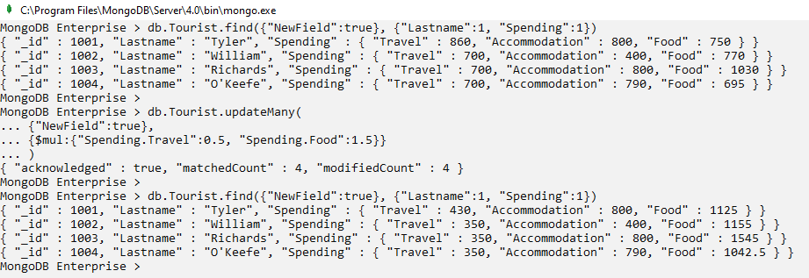

1. **For newly added male tourists, add hiking and cycling to their interests if not present already.**

db.Tourist.updateMany(

{"NewField":true, "Gender":"Male"},

{$addToSet: {"Interests": {$each: ["Hiking", "Cycling"]}}}

)

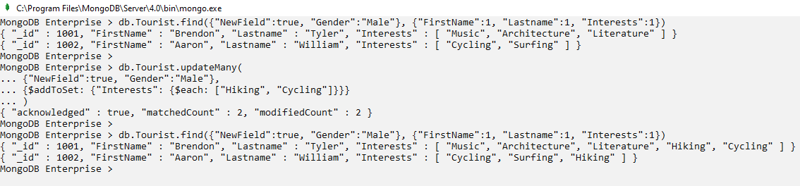

1. **For newly added tourists, create a new array named ‘Rewards’ with two fields ‘RewardCount’ and ‘Amount’ having values 1 and 200 each.**

db.Tourist.updateMany(

{"NewField":true},

{$push: {

"Rewards":{

$each:[{"RewardCount":1, "Amount":200}]

}

}

}

)

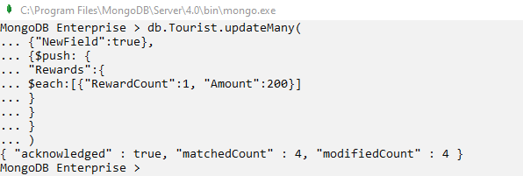

db.Tourist.find({"NewField":true}, {"FirstName":1, "Lastname":1, "Rewards":1})

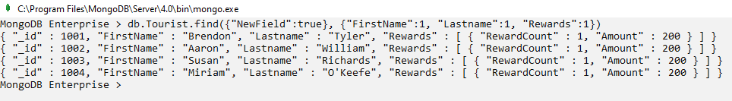

1. **For newly added female tourists, set reward amount to 300 euros and increment the reward count by 1.**

db.Tourist.updateMany(

{"NewField":true, "Gender":"Female"},

{$set: {"Rewards.$[].Amount": 300},

$inc: {"Rewards.$[].RewardCount":1}},

{multi: true}

)

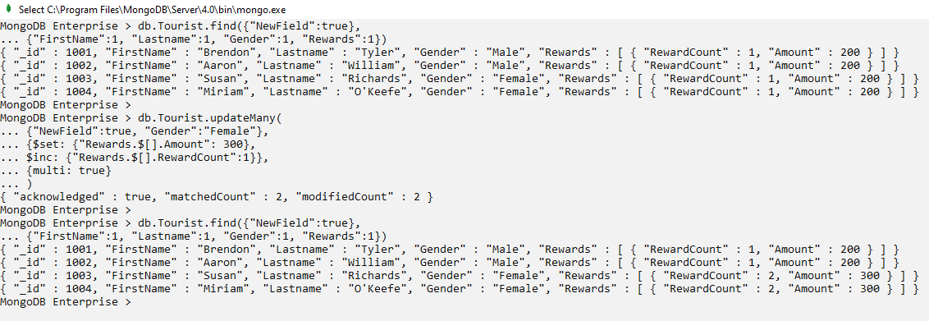

1. **Display the firstname, lastname, gender and reward details for tourists whose reward amount is greater than 250 euros.**

db.Tourist.find(

{"Rewards": {$elemMatch: {"Amount": {$gt:250}}}},

{"_id":0, "FirstName":1, "Lastname":1, "Gender":1, "Rewards":1}

).pretty()

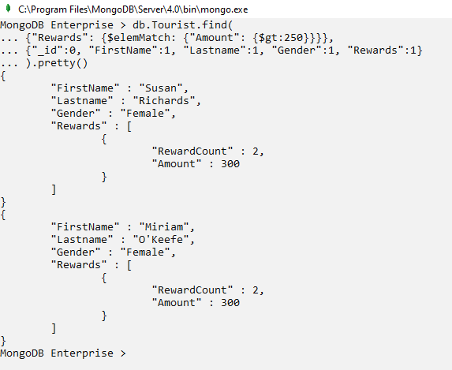

1. **Remove the first element from interests array for all newly added tourists.**

db.Tourist.updateMany(

{"NewField":true},

{$pop: {"Interests":-1}}

)

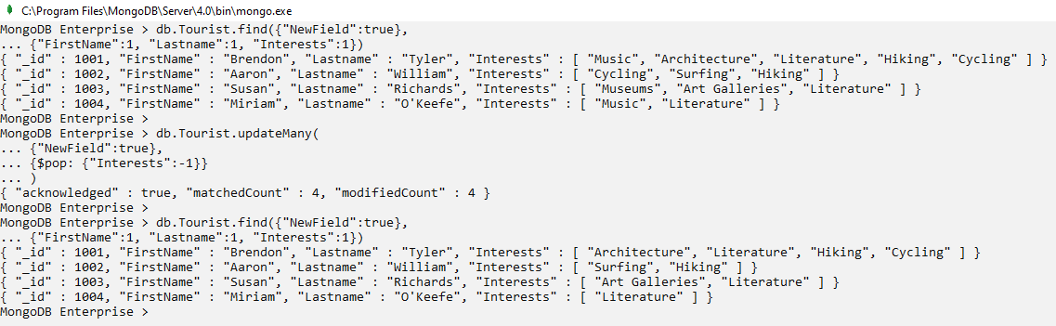

1. **For newly added tourists, remove museums from the interest and Buckingham Palace and The Colosseum from favourite destinations, if present.**

db.Tourist.updateMany(

{"NewField":true},

{$pull: {"Interests":"Museums", "Favourite_Destinations": {$in: ["Buckingham Palace","The Colosseum"]}}}

)

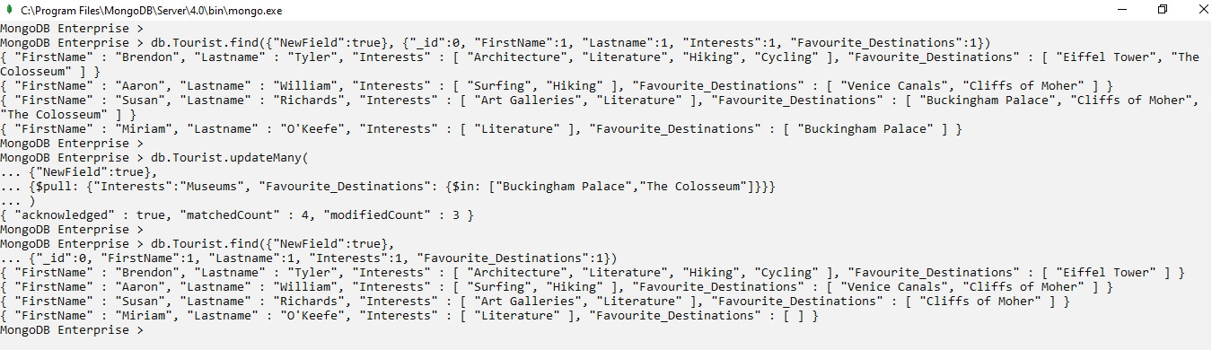

1. **From newly added tourist document, delete the field for rewards.**

db.Tourist.updateMany(

{"NewField": true},

{$unset: {"Rewards":""}}

)

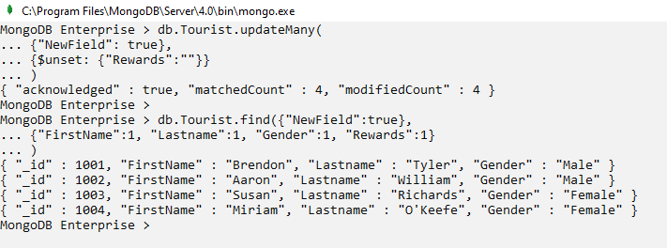

1. **Delete the first document where NewField is set true and nationality is American.**

db.Tourist.deleteOne(

{"NewField":true, "Nationality":"American"}

)

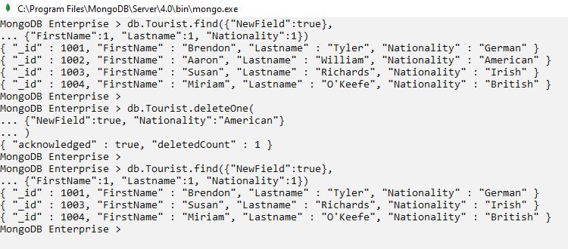

1. **Delete all the newly added tourist documents.**

db.Tourist.deleteMany(

{"NewField":true}

)

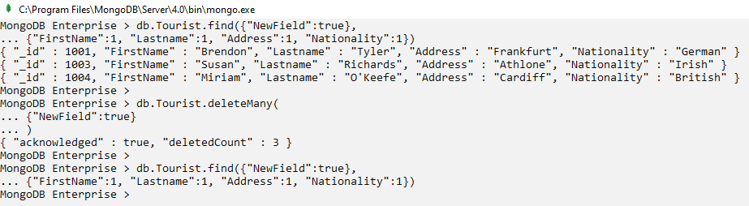

# MongoDB Shell – Aggregation Framework

1. **For student tourists who have only 1 favourite destination and have at most 200000 followers on twitter, display the lastname, status, favourite destination, the count of their interests and their number of followers on twitter.**

db.Tourist.aggregate([

{

$match: {

Status: "Student",

Favourite_Destinations: {$size: 1},

"Twitter.Num_Followers": {$lte: 200000}

}

},

{

$project: {

_id:0,

Lastname:1,

Status:1,

Favourite_Destinations:1,

InterestsCount: {$size:"$Interests"},

Followers: "$Twitter.Num_Followers"

}

}

])

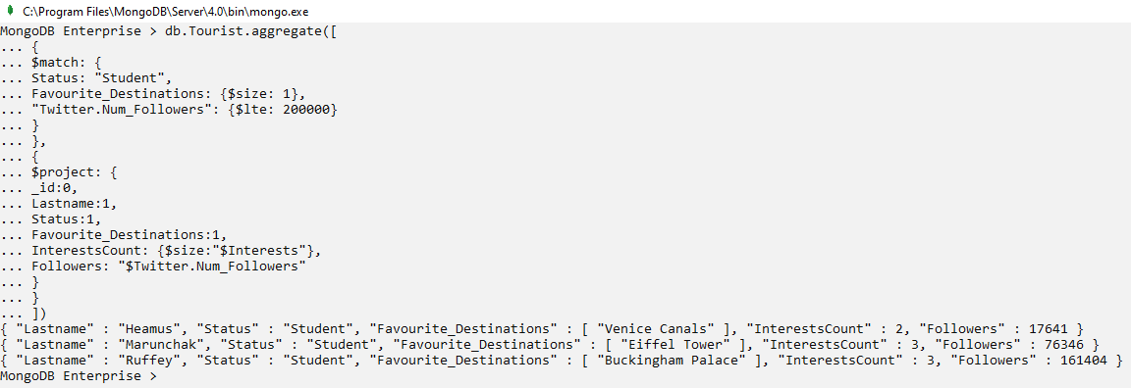

The $match stage checks all the documents and selects those where the match condition is true, so it will select those documents where status is student, has only one favourite destination and the number of followers on twitter is less than 200000.

The $project stage displays those fields where it is set to 1 or the actual field name preceded by ‘$’ symbol. Thus, output will display the lastname, status, favourite destination, count of interests array and number of followers on twitter.

1. **For each year since 2000, display the count of tourists having same year of birth. Arrange the result in increasing order of year.**

db.Tourist.aggregate([

{

$match: {"Year_Born": {$gte: 2000}}

},

{

$group: {

_id: "$Year_Born",

num_tourists: {$sum:1}

}

},

{$sort: {_id:1}}

])

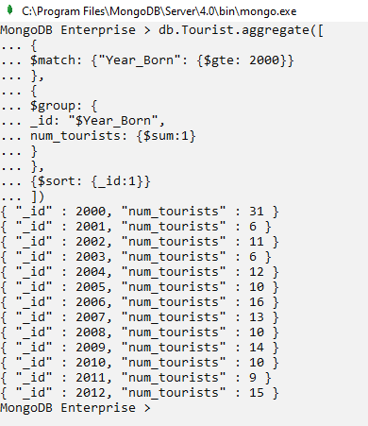

The $match stage selects those documents where the *Year_Born* field is greater than or equal to 2000.

The $group stage creates groups based on the specified *_id* field. In this case the *id* is *Year_Born* so this pipeline stage will make a group for each year since 2000. A new field named *num_tourists* is introduced to store the count of tourists that lies under each group. For each document that falls in a group, the *num_tourists* field will be incremented by 1 and finally it will represent the count of documents that belongs to that group.

The $sort stage arranges the output in ascending order of *_id* since it is set to 1.

1. **For different counts of interests, display the number of tourists having that number of interests and the average spending for that count of interests. Sort the result in decreasing order of interests count.**

db.Tourist.aggregate([

{

$group: {

_id: {

countInterests: {$size: "$Interests"}

},

num_tourists: {$sum:1},

avg_spending: {

$avg: {

$sum: ["$Spending.Travel", "$Spending.Accommodation", "$Spending.Food"]

}

}

}

},

{

$sort: {"_id.countInterests": -1}

}

])

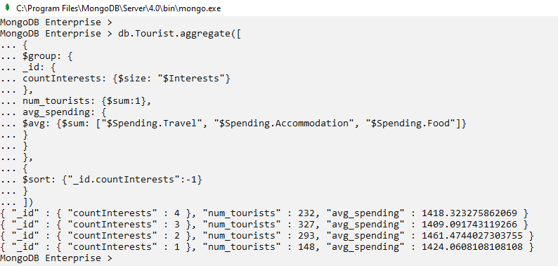

The $group stage creates groups based on the count of items in interests array in a new field called *countInterests*. The new field *num_tourists* increment its count for each group once a document fits the criteria for that group. The new field *avg_spending* calculates the overall average expense of a group after summing the travel expenses, accommodation expenses and food expenses for all the tourists within that group.

The $sort stage arranges the output in descending order of *countInterests* since it is set to -1.

1. **For each individual place present in the favourite destination array, find the count of retired British and Irish tourists who has it in their list of favourite destinations. Arrange the result in decreasing order of tourist count.**

db.Tourist.aggregate([

{$match: {

Nationality: {$in: ["British","Irish"]},

Status: "Retired"

}

},

{

$unwind: "$Favourite_Destinations"

},

{

$group: {

_id: "$Favourite_Destinations",

num_tourists: {$sum: 1}

}

},

{

$sort: {"num_tourists": -1}

}

])

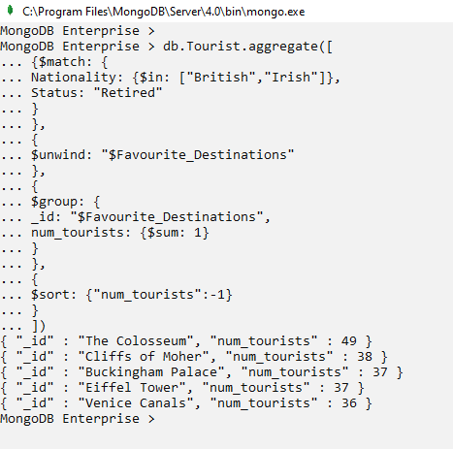

The $match stage selects those documents where nationality is either British or Irish and status is retired.

The $unwind stage deconstructs the favourite destinations array to get individual elements of the array which will be used later on in the next stage.

The $group stage creates groups based on each individual item in favourite destinations and the new field *num_tourists* calculates the count of tourists for each favourite destination.

The $sort stage arranges the output in decreasing order of *num_tourists*.

1. **For tourists born after 1980 and who have a twitter account, display the total count of tourist per 100000 based on their number of following on twitter (for example, tourists having twitter number of following between 0 and 99999 should be clubbed together, between 100000 and 199999 should be clubbed together and so on) and the average number of following for that group .**

db.Tourist.aggregate([

{$match: {Year_Born: {$gt: 1980}, "Twitter": {$ne: null}}},

{$bucket: {

groupBy: "$Twitter.Num_Following",

default: "Other",

boundaries: [0, 100000, 200000, 300000, 400000, 500000, 600000, 700000, 800000, 900000, 1000000],

output: {

count_Tourist: {$sum:1},

avg_Num_Following: {$avg: "$Twitter.Num_Following"}

}

}

}

])

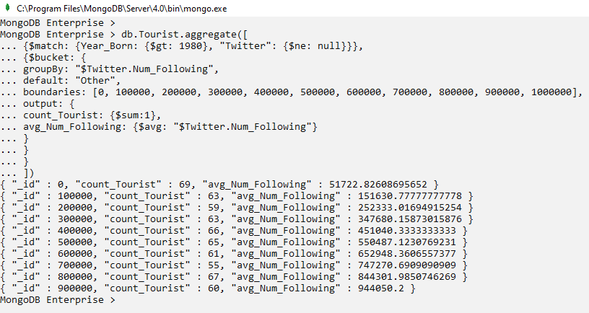

The $match stage selects those documents where *Year_Born* is greater than 1980 and *Twitter* field is not null.

The $bucket stage creates different buckets for the field specified in the *groupBy* option based on the specified boundaries. In this case buckets are created for twitter number of following with boundaries on every 100000 number of following. So, first bucket consists of those documents where twitter number of following lies between 0 (inclusive) and 100000 (exclusive) and similary second bucket consists of those documents where twitter number of following lies between 100000 (inclusive) and 200000 (exclusive) and so on. The output option specifies which fields will be displayed in the output apart from the bucket id.

1. **For all the French tourists, display the count of tourists based on their address and divide the tourists into 5 groups based on their total expenditure such that each group has similar count of tourists.**

db.Tourist.aggregate([{

$match: {Nationality: "French"}},

{$facet: {

Address: [{$sortByCount: "$Address"}],

Total_Expense: [{$bucketAuto:{

groupBy: {$add: ["$Spending.Travel", "$Spending.Accommodation", "$Spending.Food"]},

buckets: 5

}

}]

}

}]).pretty()

The $match stage selects those documents where nationality matches with French.

The $facet stage allows to represent the output of the previous stage with a new aspect according to the provided facet conditions. It can be said that this stage supplies additional filters and categorizations to analyze the output. In this case the, first facet condition shows each address in France with the count of tourists having that address in descending order. The second facet stage creates 5 automatic buckets i.e., boundaries will be selected automatically based on the count of data, for the total spending of tourists under the name *Total_Expense*.

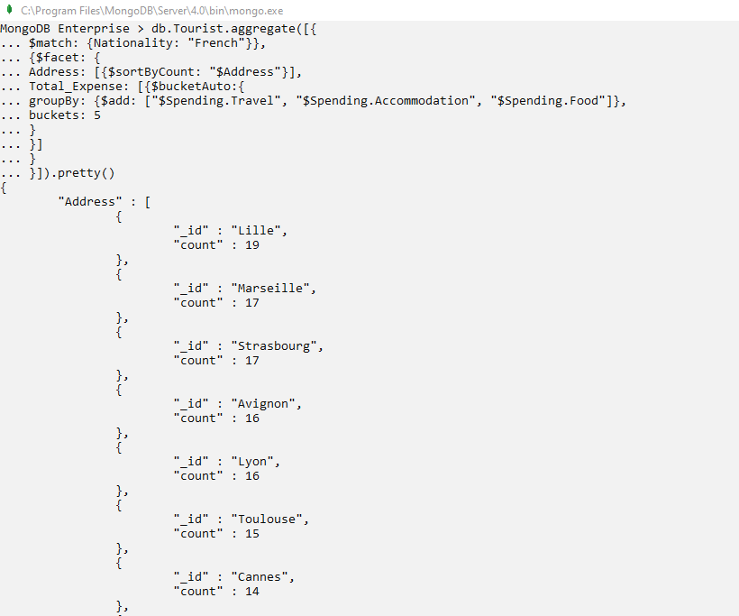

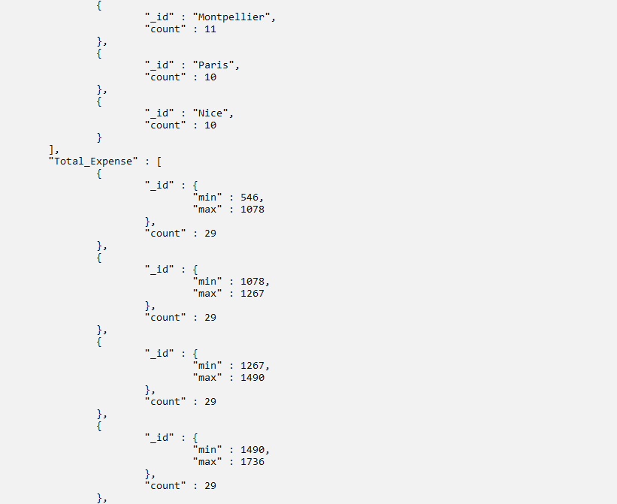

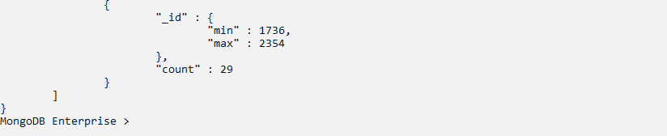

1. **For tourists who use only twitter and no other social media, identify their influence on twitter based on their number of followers. If number of followers are greater than 500000 then categorize them as “Heavy influencer”, if number of followers are between 250000 and 500000 then categorize them as “Moderate influencer” and if the number of followers are less than 250000 then categorize them as “Low influencer”. Display their firstname, lastname, number of followers on twitter and the remark based on the number of followers.**

db.Tourist.aggregate([

{

$match: {

Social_Media: null, Twitter: {$exists: true}

}

},

{

$project: {

"_id":0,

"FirstName":1,

"Lastname":1,

"Twitter.Num_Followers":1,

"Twitter_Remark":

{$switch: {

branches: [

{

case: {$gte: ["$Twitter.Num_Followers",500000]},

then: "Heavy influencer"

},

{

case:{$and: [

{$gte: ["$Twitter.Num_Followers",250000]},

{$lt: ["$Twitter.Num_Followers",500000]}

]},

then: "Moderate influencer"

},

{

case: {$lt: ["$Twitter.Num_Followers",250000]},

then: "Low influencer"

},

],

default: "No Num_Followers found"

}

}

}

}

])

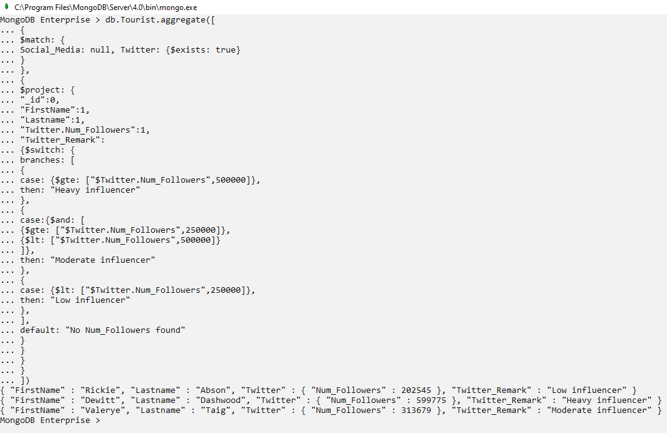

The $match stage selects those documents where social media field is null and twitter field exists.

The $project stage hides the *_id* field and displays only firstname, lastname, twitter’s number of followers and adds a new field named *Twitter_Remark*, which uses *Switch* cases to display “Heavy influencer” if number of followers are greater than or equal to 500000, “Moderate influencer” if the number of followers are greater than or equal to 250000 but less than 500000 and “Low influencer” if the number of followers are less than 250000.

1. **Create a permanently stored query (view) which contains information for only those tourists who are on career break. The query should not display information about special needs, payment method, interests, favourite destinations, social media and twitter.**

db.createView("Career_Break_Tourist", "Tourist",[

{$match: {Status: "Career Break"}},

{

$project: {

_id: 0,

Name: {

$concat: [

{$cond: [{$eq: ["$Gender", "Female"]}, "Ms.", "Mr."]},

"$FirstName", " ", "$Lastname"

]

},

Address: 1,

Nationality: 1,

Year_Born: 1,

Status: 1,

Telephone_No: 1,

Email_Address: 1,

Spending: 1,

}

}

])

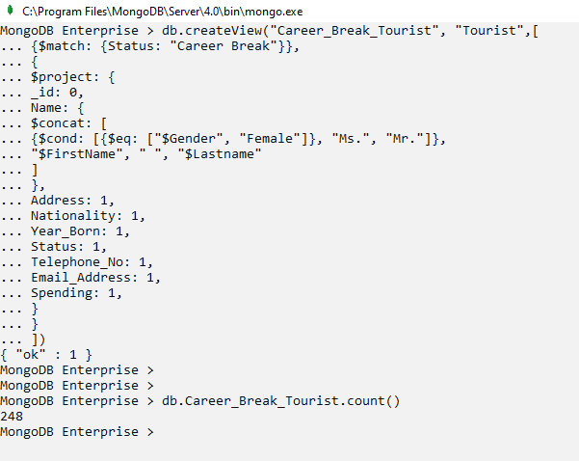

The $match stage selects those documents where status is career break.

The $project stage specifies which fields will be displayed when the view is queried. A new field called *Name* is introduced to display the full name of the tourist with appropriate title. Apart from the name, the view will display address, nationality, birth year, status, telephone number, email address and spending details.

1. **From the Career_Break_Tourist view, display the name, address, birth year and spending details of those tourists whose address begins with T and whose travel expense is greater than 500.**

db.Career_Break_Tourist.find(

{"Address": {$regex: /^T.*/},

"Spending.Travel": {$gt: 500}},

{Name:1, Address:1, Year_Born:1, Spending:1}

)

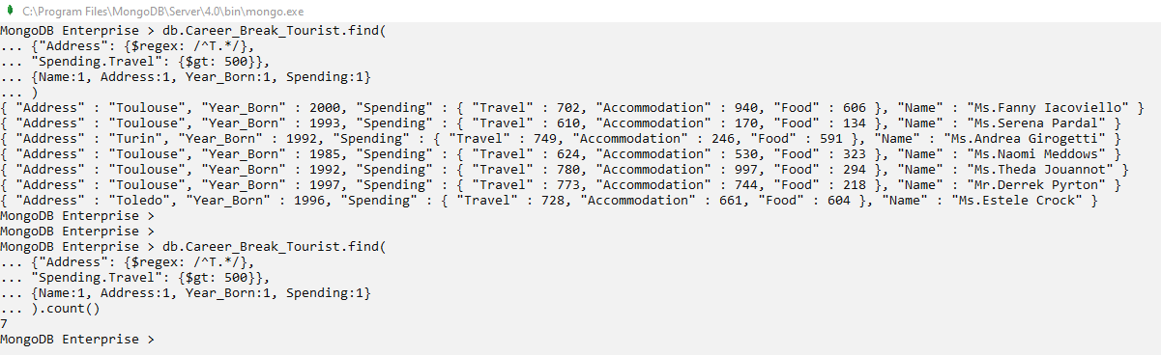

The views in MongoDB are similar to views in SQL. They don’t store any data and reflect the data from the collection. They are read-only and the data can be queried using find() or aggregate() functions.

In this case, the query will return details for those tourists whose address begins with T and whose travel expenditure is greater than 500 in addition to the conditions specified in the view.

1. **From the Career_Break_Tourist view, display the count of tourists for each year from 1990 to 2000 who are born in these years. Arrange the results in ascending order of year.**

db.Career_Break_Tourist.aggregate([

{$match: {Year_Born: {$gte: 1990, $lt: 2001}}},

{

$group: {

_id: "$Year_Born",

touristsCount: {$sum: 1}

}

},

{

$sort: {"_id": 1}

}

])

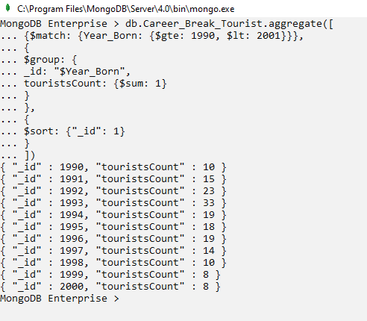

The $match stage will select those tourists whose birth year is greater than or equal to 1990 and less than 2001 and the conditions mentioned in the view definition.

The $group stage will create groups for the individual years from 1990 to 2000 and calculate the count of tourists for each group whose birth year is same as group id.

The $sort stage will arrange the output in increasing order of group id i.e., the year_born.

1. **A tourist named Mr. Elijah Elis wants to find out how many meals worth 75 euros were purchased by him based on his spendings. Display the break-up for his food expenses by querying the view Career_Break_Tourist.**

db.Career_Break_Tourist.aggregate([

{$match: {Name: "Mr.Elijah Elis"}},

{

$project: {

Name:1,

"Spending.Food": 1,

"Meal Expense breakup": {

$range: [0, "$Spending.Food", 75]

}

}

}

])

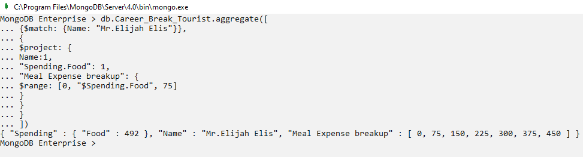

The $match stage selects that document where Name matches with Elijah Elis and the view conditions.

The $project stage displays the name, food expense and the numbers from 0 to the available food spending amount for that tourist skipping 75 numbers in between. So, Mr. Elijah Elis had 7 meal each costing 75 euros if he spent a total of 492 euros on food.

Delete the view from the database.

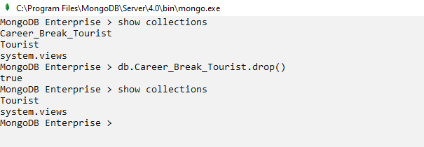

# MongoDB Compass Overview

MongoDB Compass is a GUI for MongoDB. It allows the users to write queries and explore the data visually. Users can connect their local database or databases from Sandbox cluster with Compass and interact with data with complete CRUD (Create, Read, Update and Delete) functionality.

Apart from simple MongoDB queries, Compass also provides

Steps to access local databases using MongoDB Compass

1. Open MongoDB Compass and click on *Connect*.

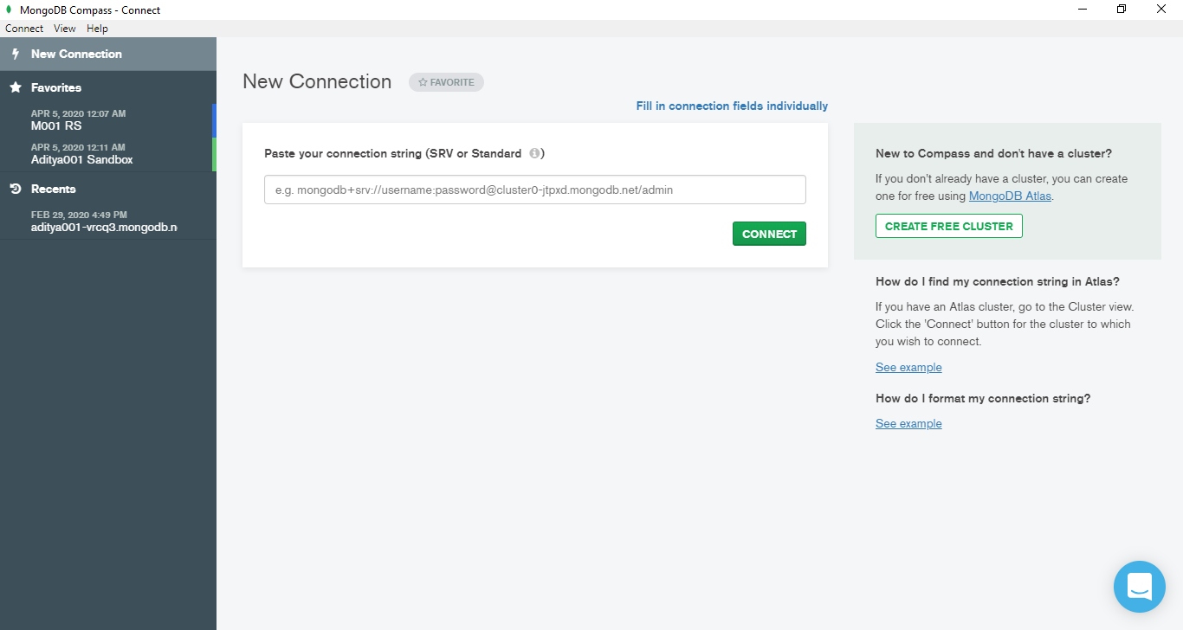

Figure 1: MongoDB Compass’s new connection page

1. The local MongoDB databases are now connected to the Compass. Click on the database that we wish to load, in this case, we will use *MSC_DA* database.

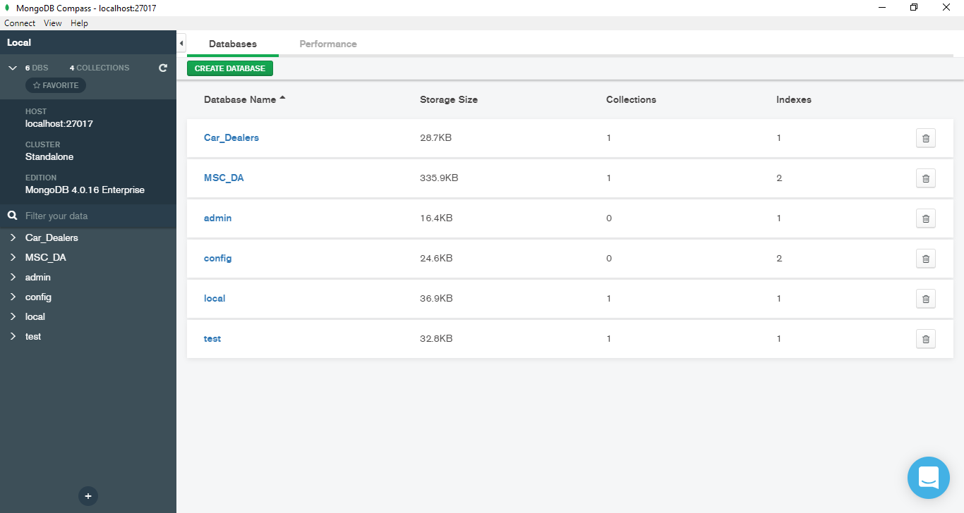

Figure 2: Local databases that can be accessed by the Compass

1. Click on the database to see the collections stored in the database. In this case a collection named *Tourist* exists in the database which will be used for this project. To load another collection, we can use the *Create Collection* option.

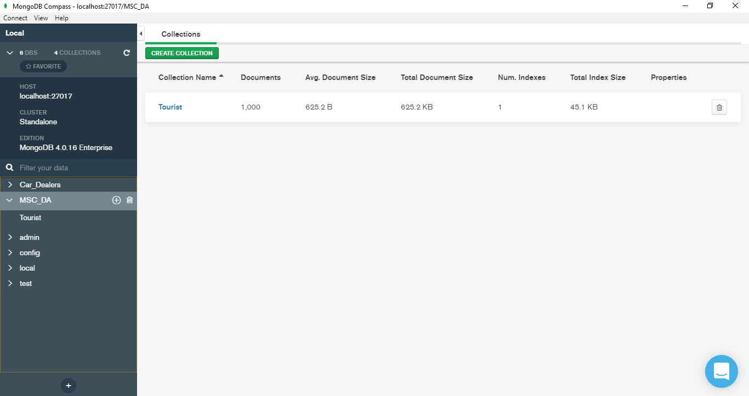

Figure 3: Collections within the database

1. Click on the *Tourist* collection to look at the documents inside the collection.

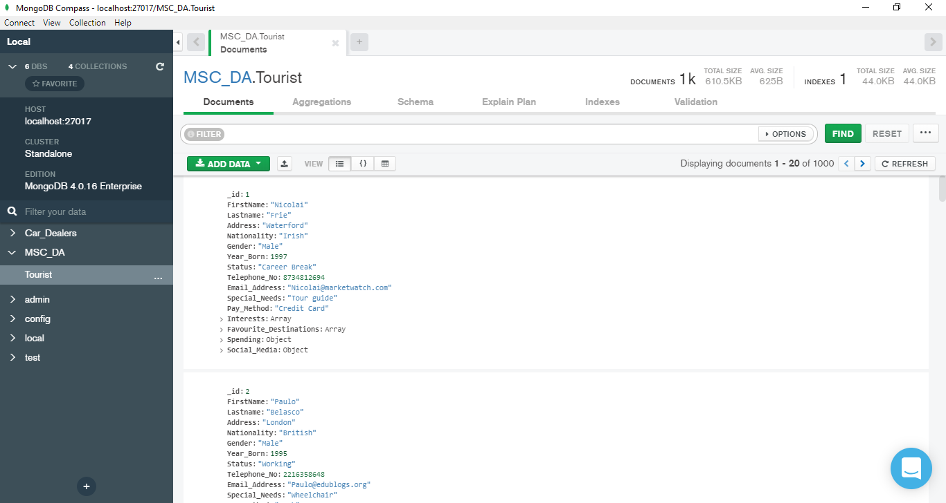

Figure 4. Documents inside the collection

# MongoDB Compass – Simple Queries

1. **Display the firstname, lastname, nationality, gender, pay method, interests and special needs of male French tourists who need tour guide and have interest in at least hiking and cycling.**

Filter -

{Nationality:"French", Gender:"Male", Special_Needs:"Tour guide", Interests: {$all:["Hiking","Cycling"]}}

Project -

{"_id":0, "FirstName":1, "Lastname":1, "Nationality":1, "Gender":1, "Pay_Method":1, "Interests":1, "Special_Needs":1}

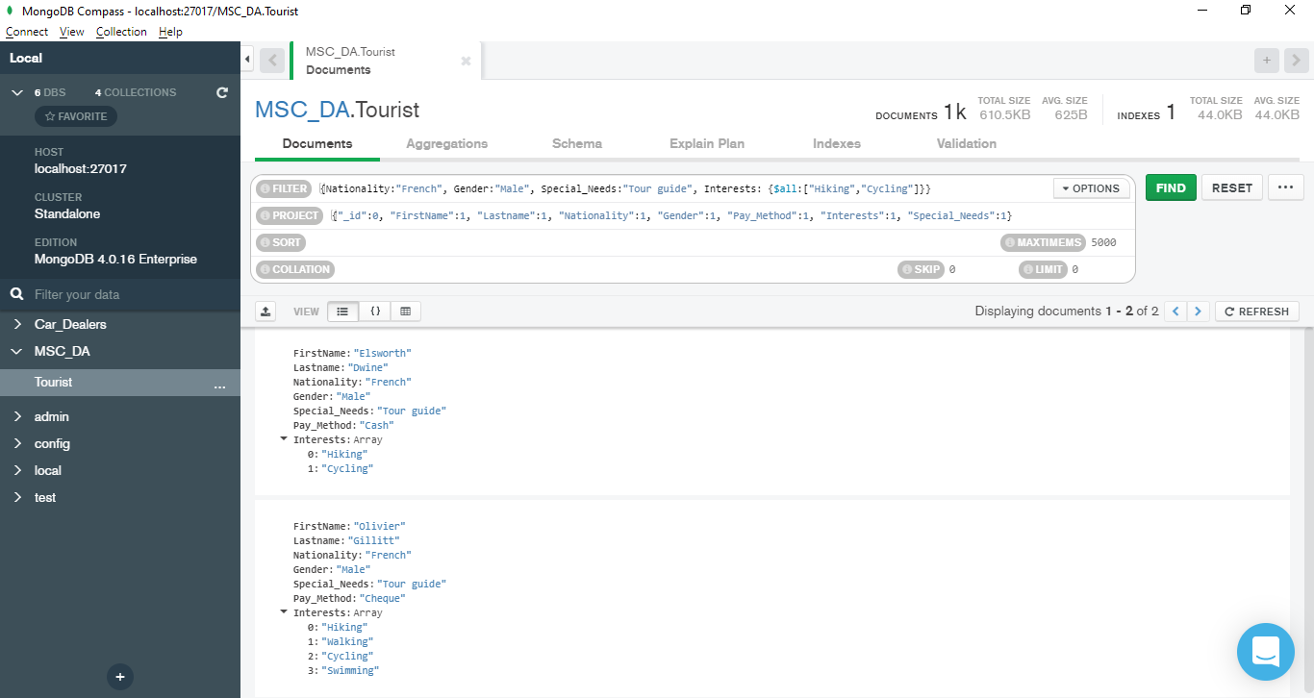

1. **Display the id, lastname, gender, pay method, amount spent on food and favourite destinations for those tourists whose last name end with letter ‘ke’, spend outside 200 and 500 euros on food and do not have 4 favourite destinations.**

Filter -

{"Lastname":{$regex: /ke$/}, $or:[{"Spending.Food":{$lt:200}},{"Spending.Food":{$gt:500}}], "Favourite_Destinations":{$not:{$size:4}}}

Project -

{"Lastname":1, "Gender":1, "Pay_Method":1, "Spending.Food":1, "Favourite_Destinations":1}

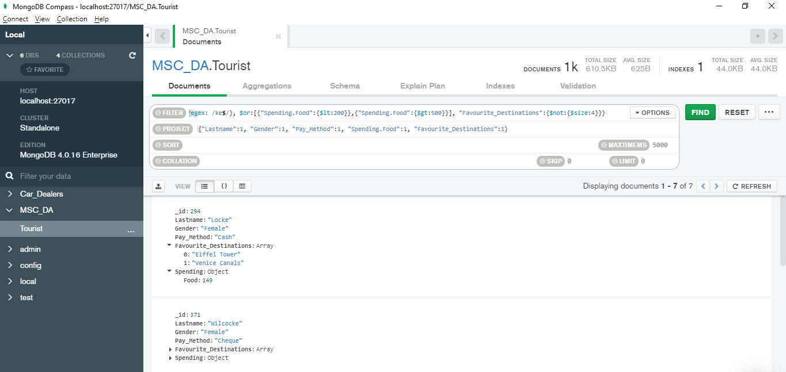

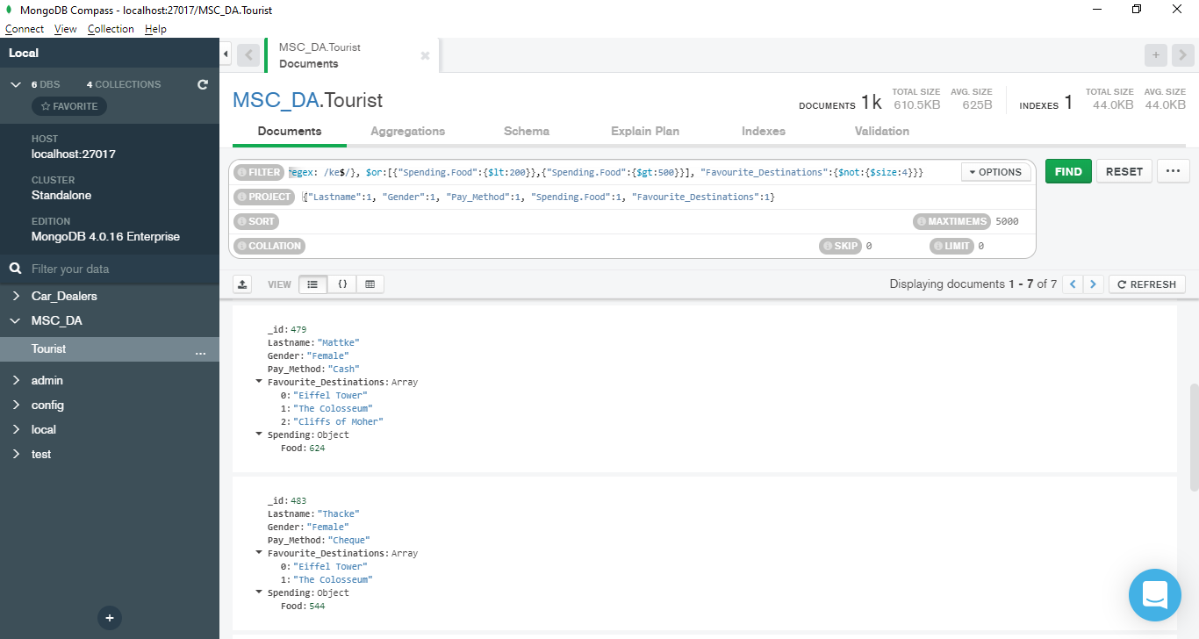

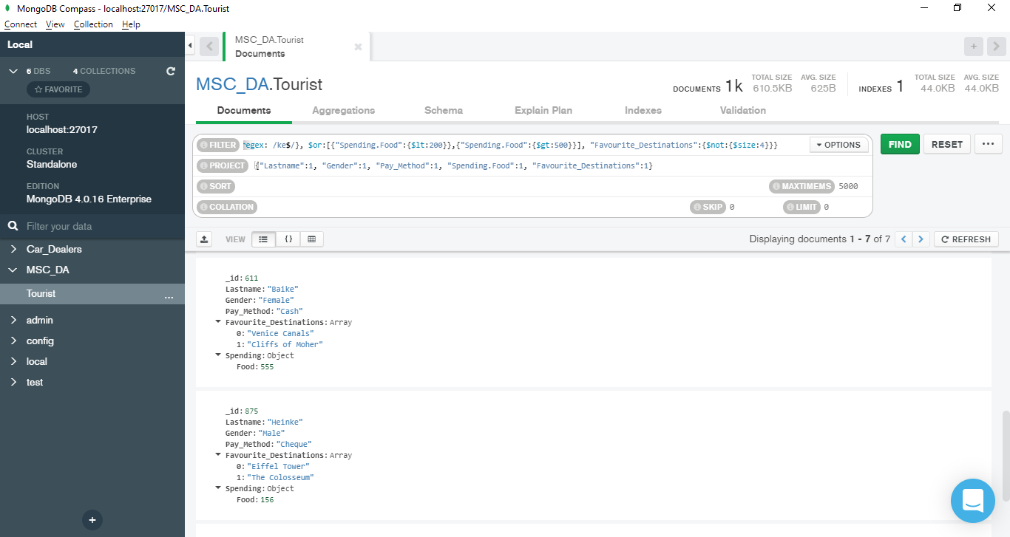



1. **Display the firstname, address, nationality, birth year, status, special needs and spendings of those tourists who do not have a twitter account, whose expenditure on food is greater than expenditure on accommodation and who are born in the year 2005,2006 or 2007. Arrange the results in ascending order of nationality.**

Filter -

{"Twitter":{$exists:false},$expr: {$gt:["$Spending.Food","$Spending.Accommodation"]},"Year_Born":{$in:[2005,2006,2007]}}

Project -

{"_id":0, "FirstName":1, "Address":1, "Nationality":1, "Year_Born":1, "Status":1, "Special_Needs":1, "Spending":1, "Twitter":1}

Sort -

{"Nationality":1}

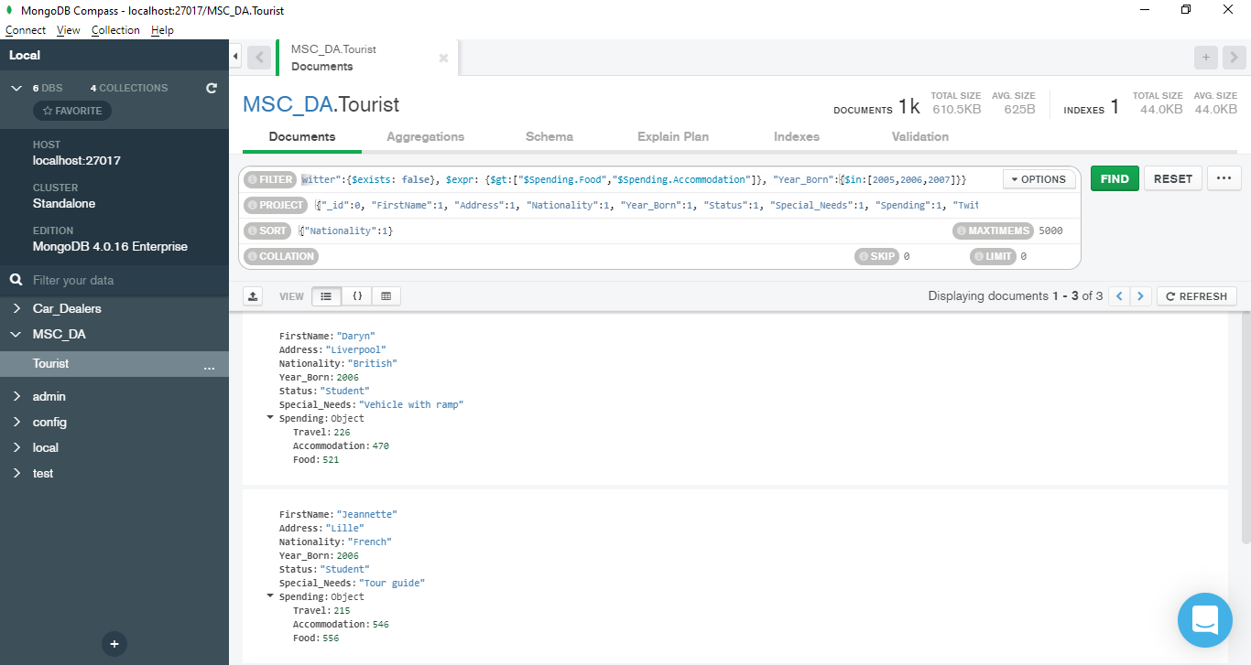



# MongoDB Compass – Aggregation Framework

1. **For student tourists who have only 1 favourite destination and have at most 200000 followers on twitter, display the lastname, status, favourite destination, the count of their interests and their number of followers on twitter. (For query explanation, refer to question number 1 of MongoDB Shell – Aggregation Framework)**

$match –

{

Status: "Student",

Favourite_Destinations: {$size: 1},

"Twitter.Num_Followers": {$lte: 200000}

}

$project –

{

_id:0,

Lastname:1,

Status:1,

Favourite_Destinations:1,

InterestsCount: {$size:"$Interests"},

Followers: "$Twitter.Num_Followers"

}

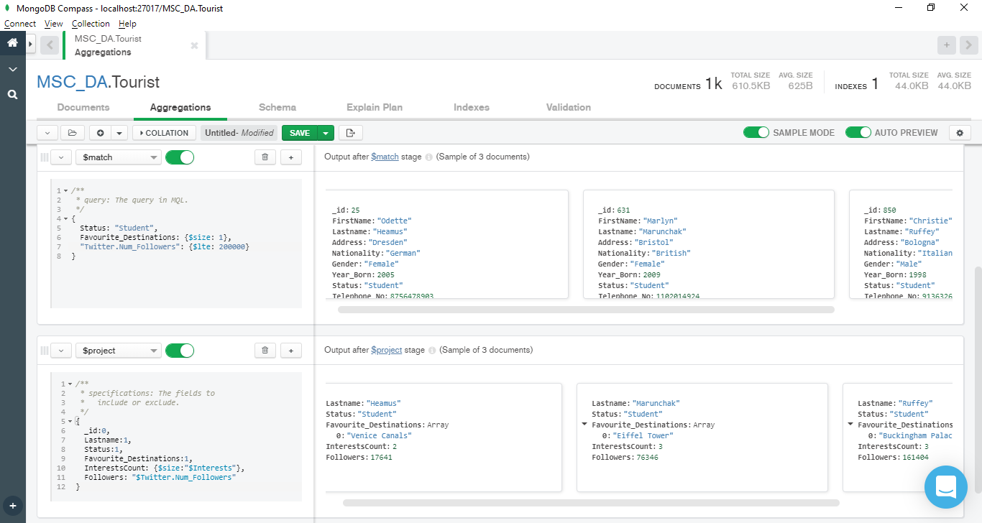

1. **For each individual place present in the favourite destination array, find the count of retired British and Irish tourists who has it in their list of favourite destinations. Arrange the result in decreasing order of tourist count. (For query explanation, refer to question number 4 of MongoDB Shell – Aggregation Framework)**

$match –

{

Nationality: {$in: ["British","Irish"]},

Status: "Retired"

}

$unwind –

{

path: "$Favourite_Destinations",

}

$group –

{

_id: "$Favourite_Destinations",

num_tourists: {

$sum: 1

}

}

$sort –

{

num_tourists: -1

}

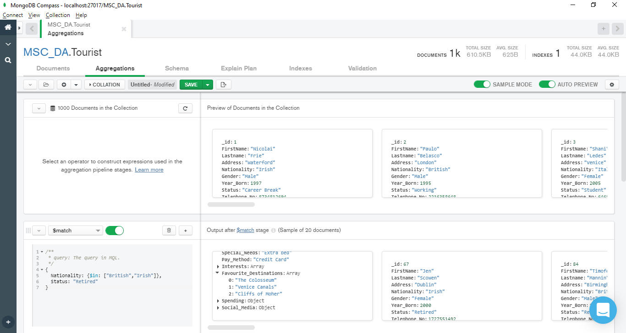

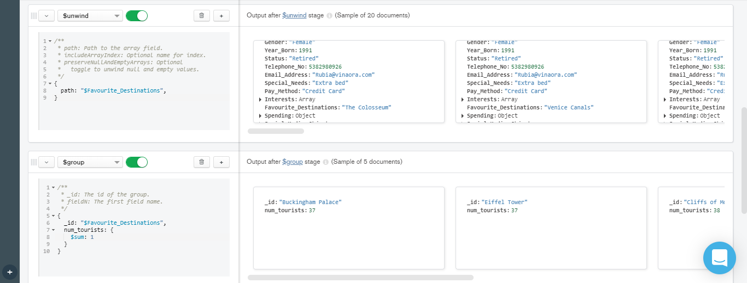

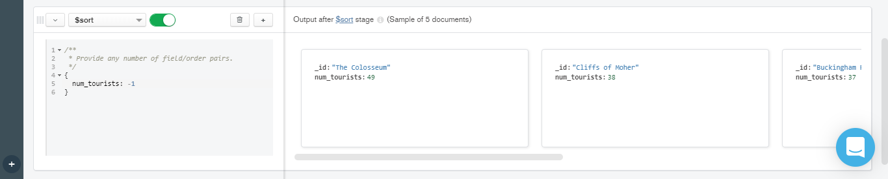

1. **For different counts of interests, display the number of tourists having that number of interests and the average spending for that count of interests. Sort the result in decreasing order of interests count. (For query explanation, refer to question number 3 of MongoDB Shell – Aggregation Framework)**

$group –

{

_id: {

countInterests: {$size: "$Interests"}

},

num_tourists: {

$sum:1

},

avg_spending: {

$avg: {

$sum: [

"$Spending.Travel",

"$Spending.Accommodation",

"$Spending.Food"

]

}

}

}

$sort –

{

"_id.countInterests": -1

}

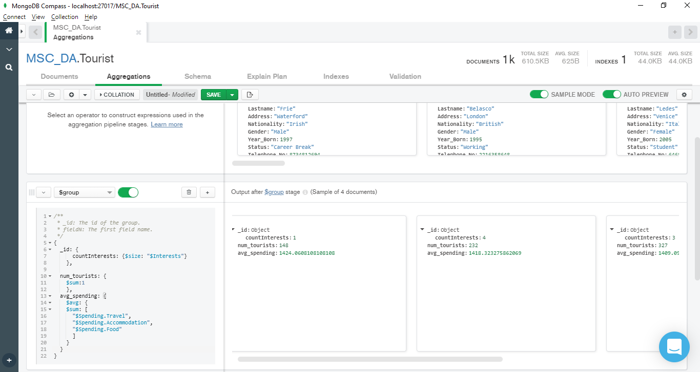

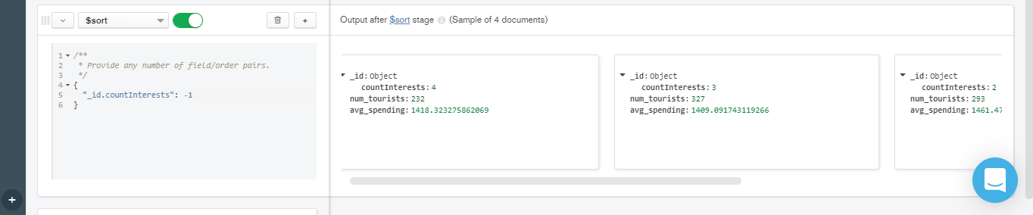

# MongoDB Atlas Overview

MongoDB Atlas is the global cloud database service for modern applications. It allows users to create their own cluster on the cloud for their databases and collections. Users can also write simple queries and aggregation queries in Atlas to get desired output.

Steps to create an Atlas cluster for MongoDB project

1. Click on the 3 dots as shown in the figure below and select *New Project* option.

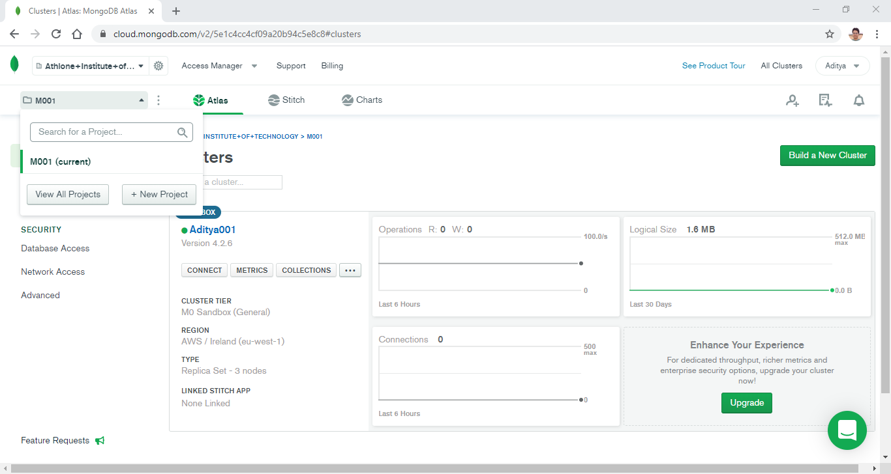

Figure 1: Create a new project

1. Give a suitable name for the project and click *Next*.

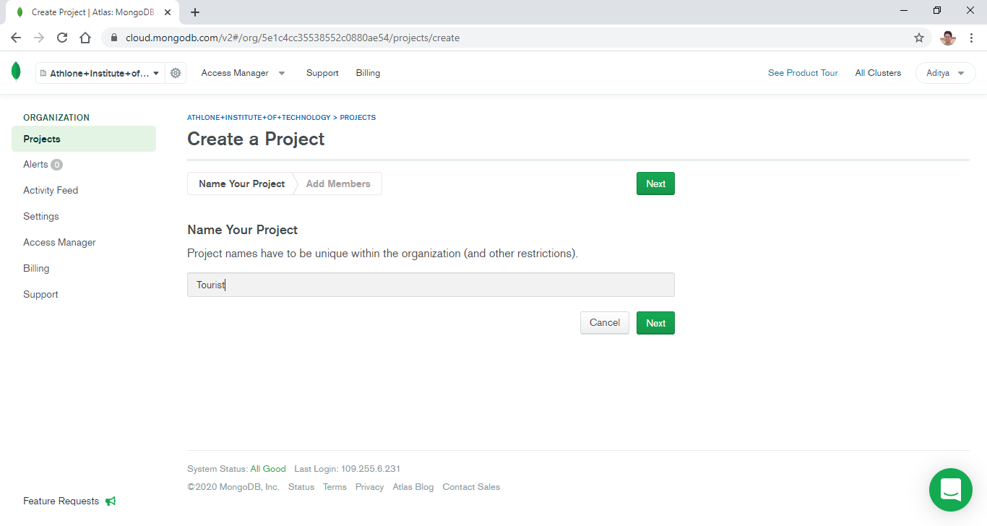

Figure2: Name the project

1. Add members and set permissions for the project if required and click on *Create Project*.

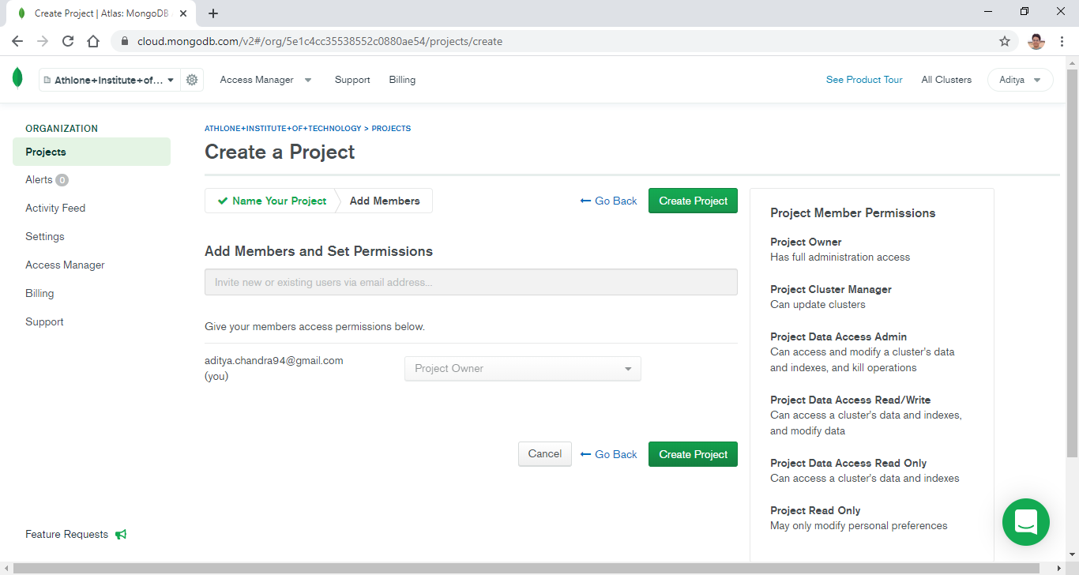

Figure 3: Add members and set permissions

1. Once the project is created, we can proceed to build the cluster by clicking on *Build a Cluster* option.

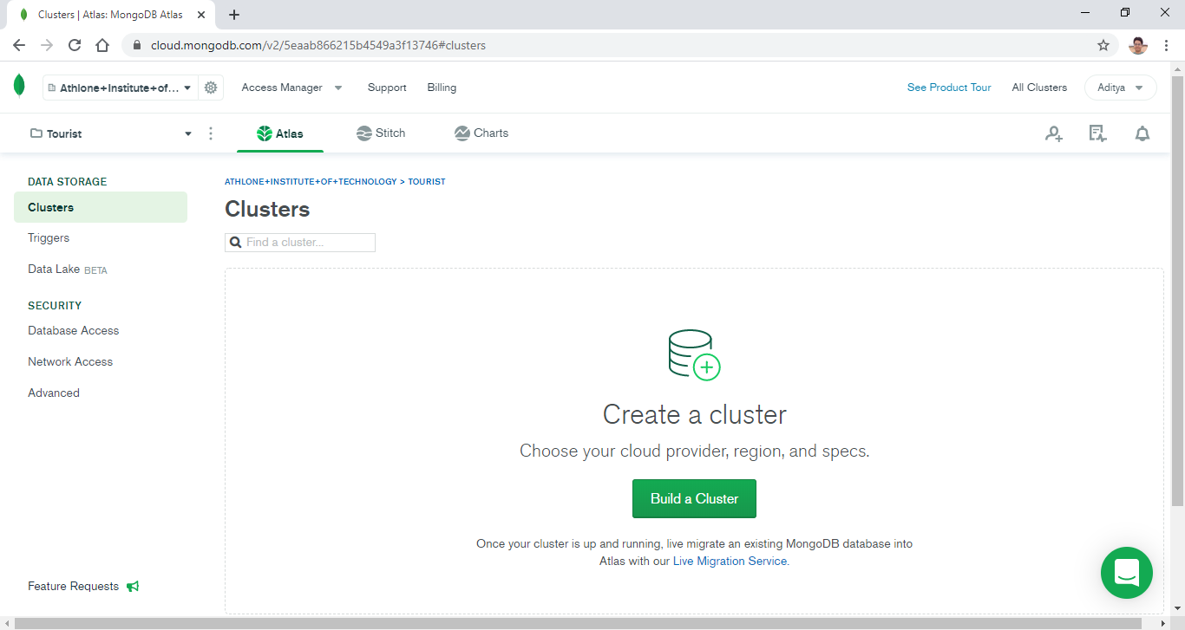

Figure 4: Build a cluster

1. Click on *Build a cluster* under the *Shared Clusters* option.

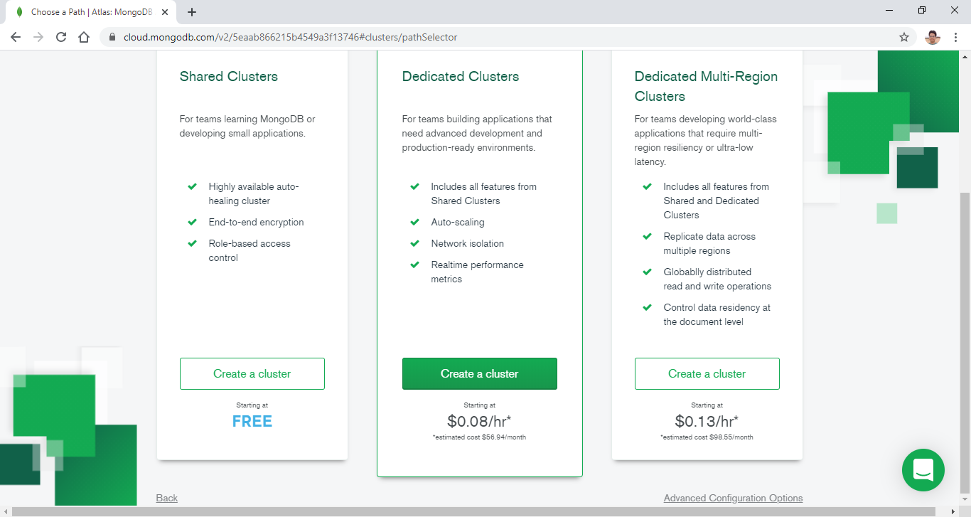

Figure 5: Build a shared cluster

1. To complete the cluster creation process, select any cloud provider such as *Amazon Web Services (AWS)* and select appropriate region for the cluster which is *Ireland (eu-west-1)* in our case then click on *Create Cluster*. In case a prompt to upgrade the cluster appears, click on continue without upgrade.

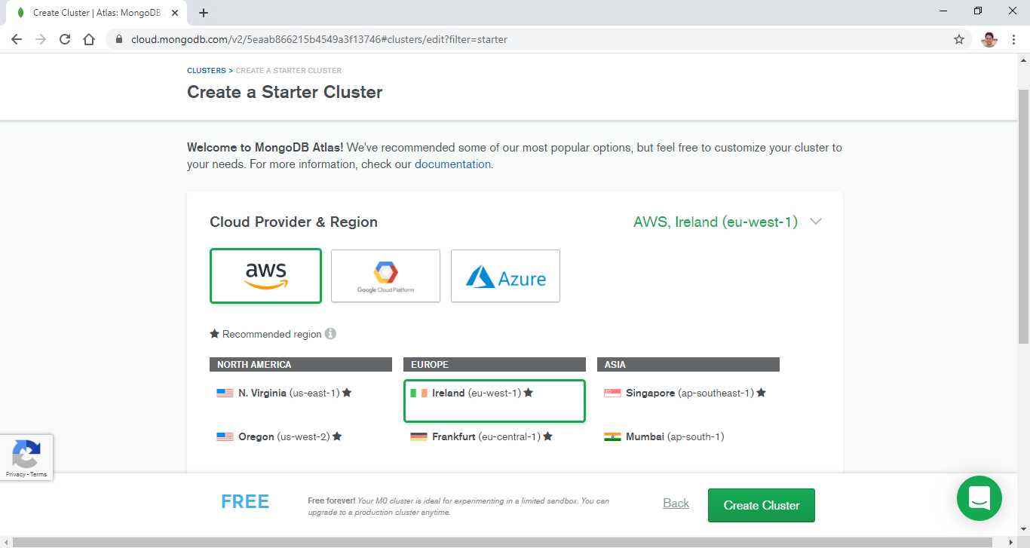

Figure 6: Select cloud provider and region for the cluster

1. The cluster takes a while to come up and running. Once the Sandbox cluster is successfully deployed, click on *Connect*.

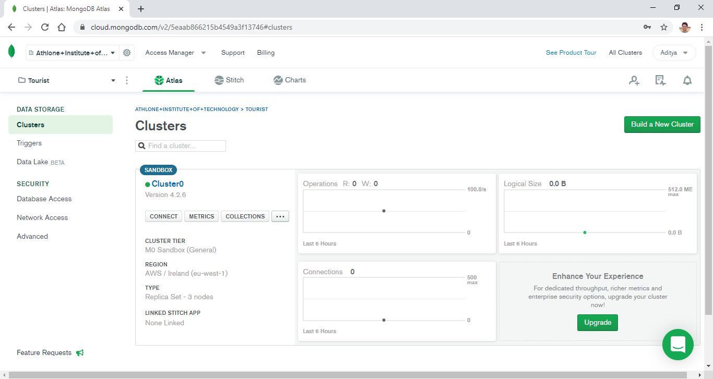

Figure 7: Successfully deployed Sandbox cluster

1. To use the Sandbox cluster for the project the IP address of the machines using the cluster needs to be whitelisted for security reasons. To add the IP address of the system being used currently, click on *Add Your Current IP Address*.

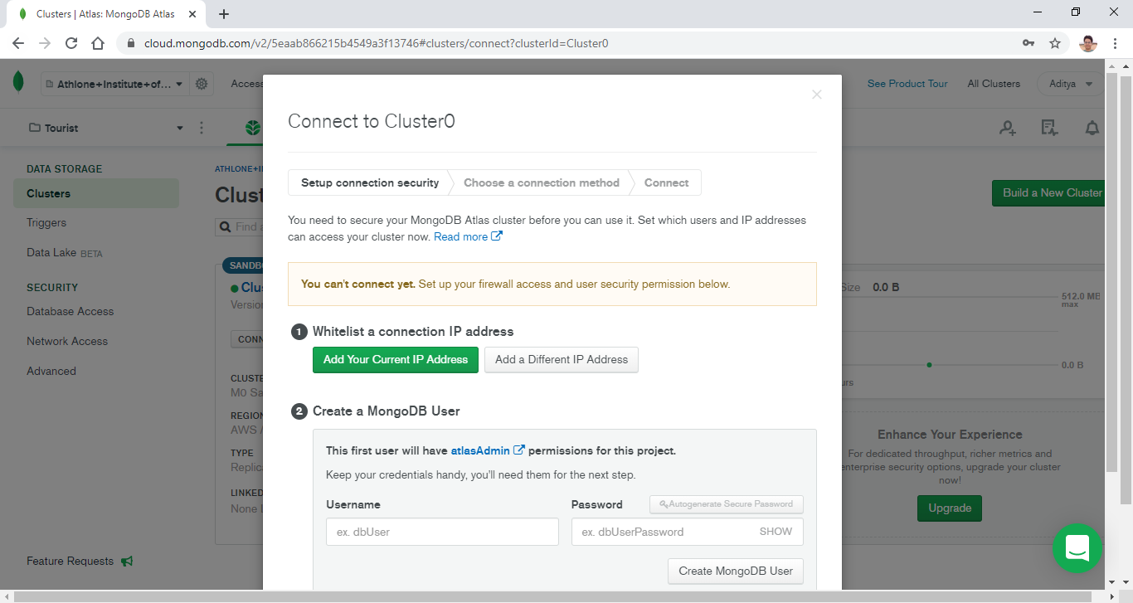

Figure 8. Whitelist a connection IP Address

1. The detected IP address of the system will be visible then click on *Add IP Address*.

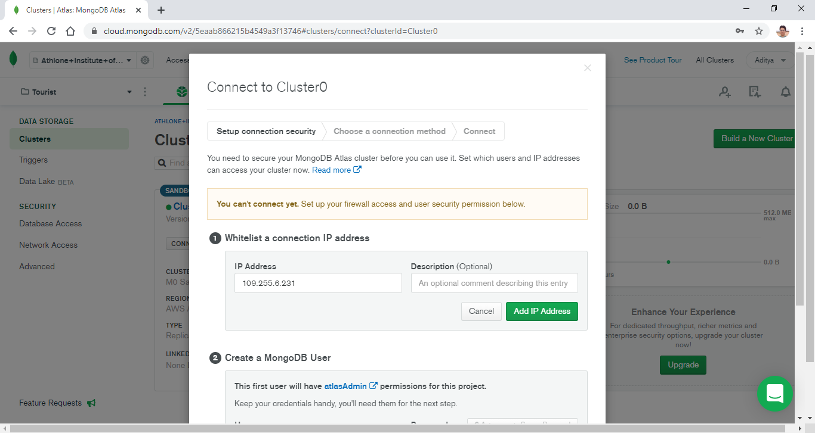

Figure 9. Add current IP Address

1. The IP address of the system that can access the Sandbox cluster is now added. But we may need to be able to access the cluster from other system. To allow that click on the link for the *IP Whitelist tab*.

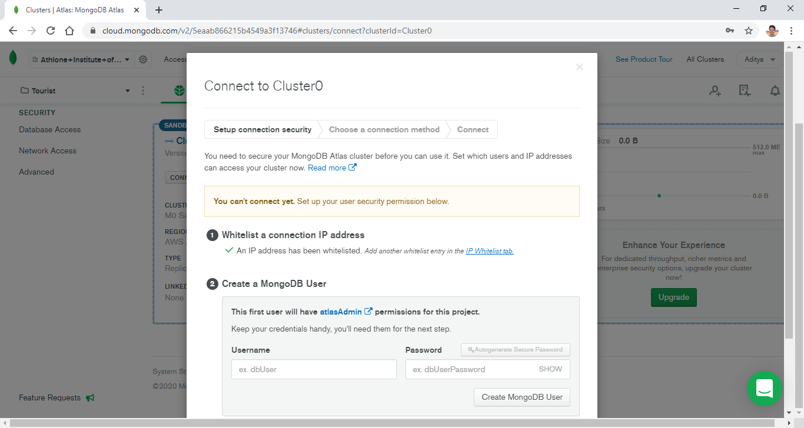

Figure 10: Whitelisted IP address

1. To change the network access parameters, click on the edit option as shown below.

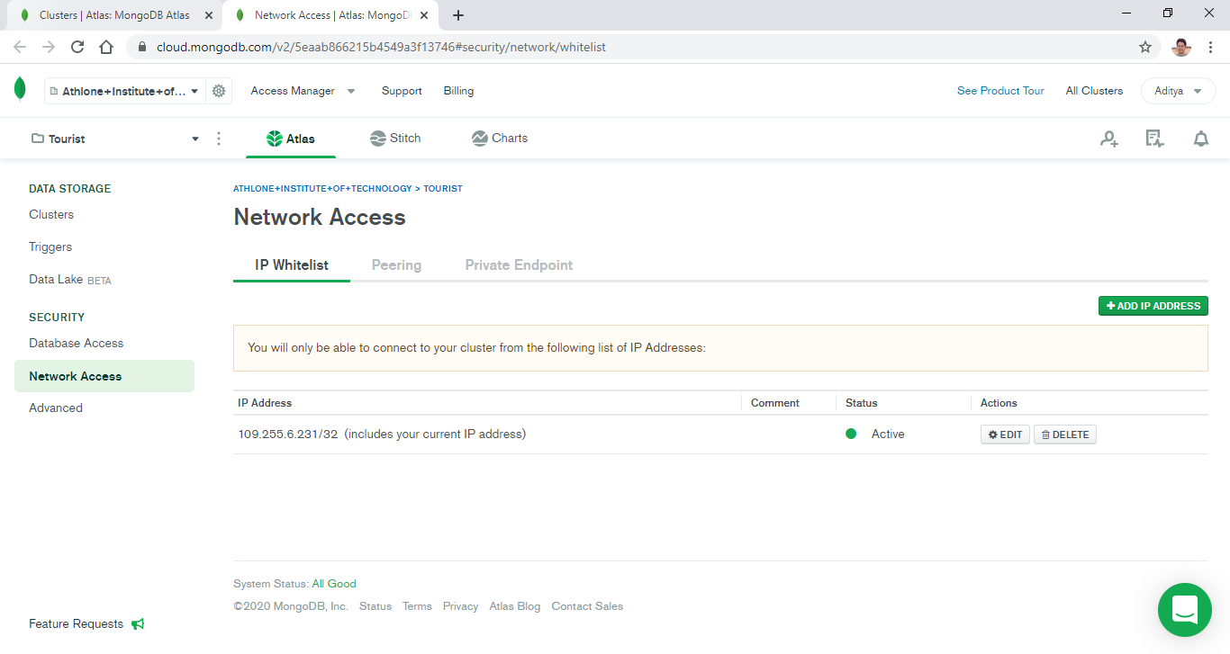

Figure 11: Edit network access IP addresses

1. Click on *Allow Access from Anywhere* as shown below.

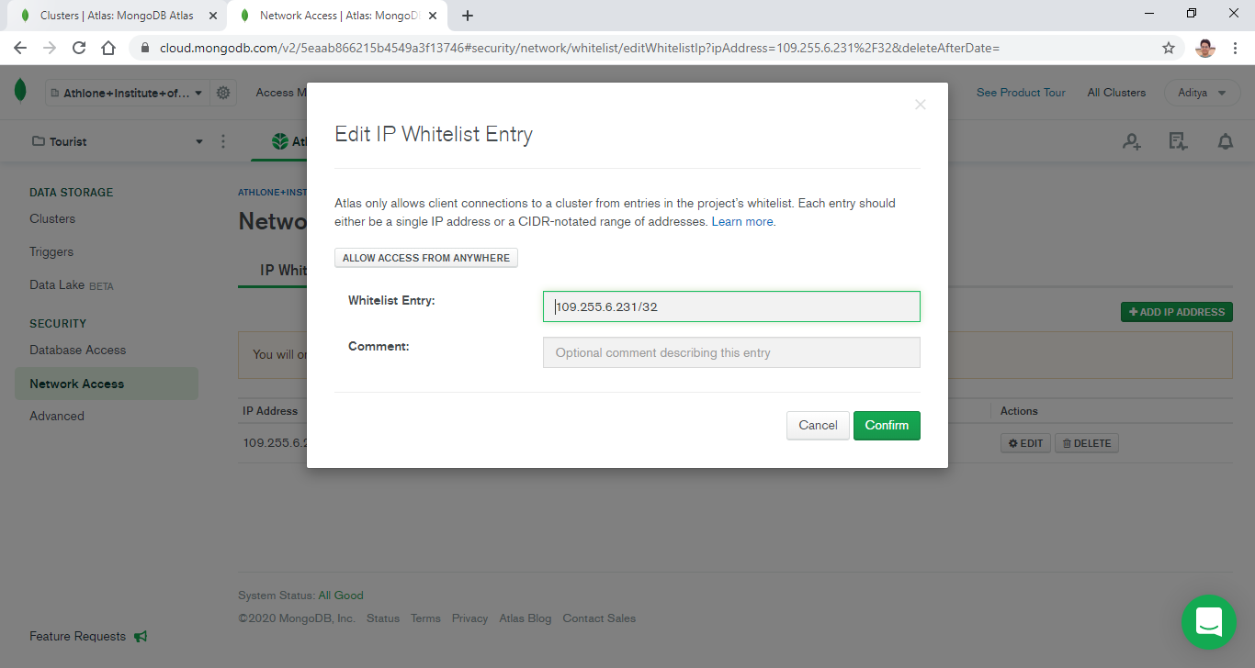

Figure 12: Edit IP whitelist entry

1. Now the whitelisted IP address changes to 0.0.0.0 which allows access from anywhere. Click on *Confirm* to proceed.

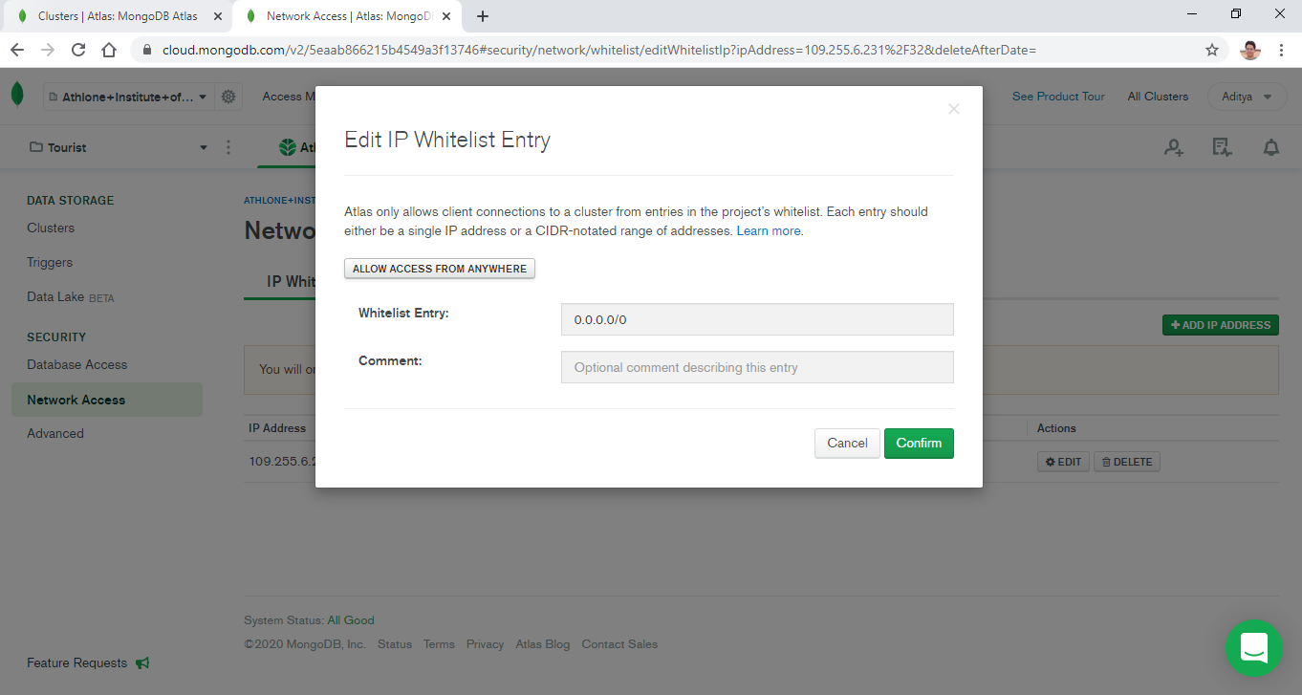

Figure 13: Allow access from anywhere

1. The next step is to create a database user which can access the cluster. To do that click on the *Database Access* option under the *Security* panel as highlighted below.

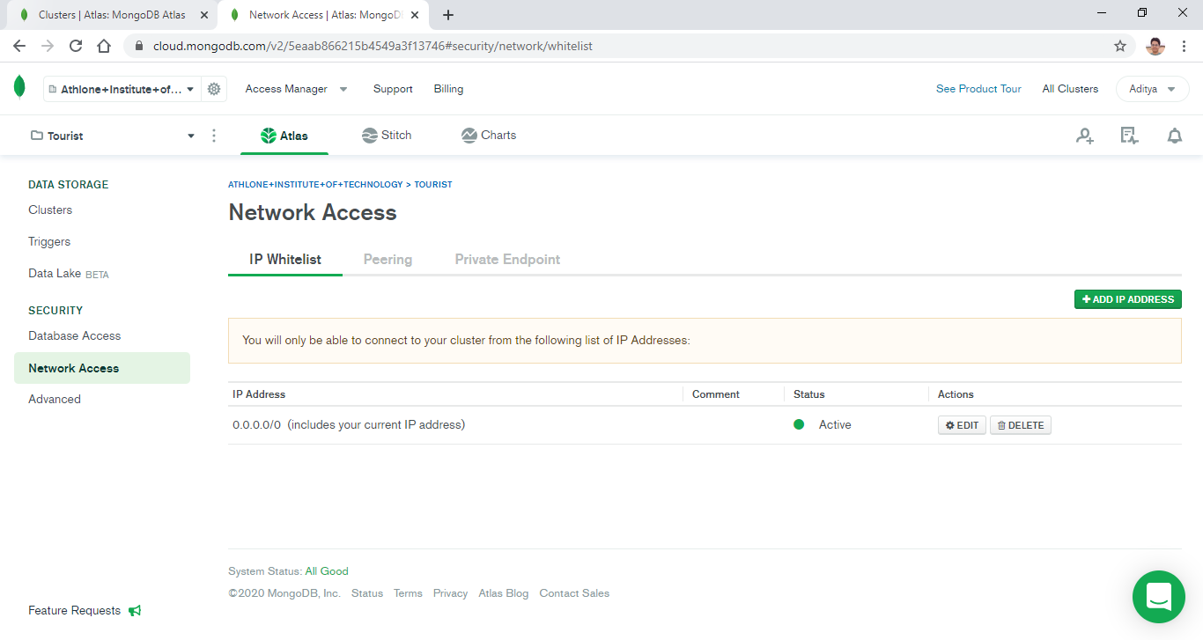

Figure 14: Database access

1. To create a new database user, click on Add *New Database User*.

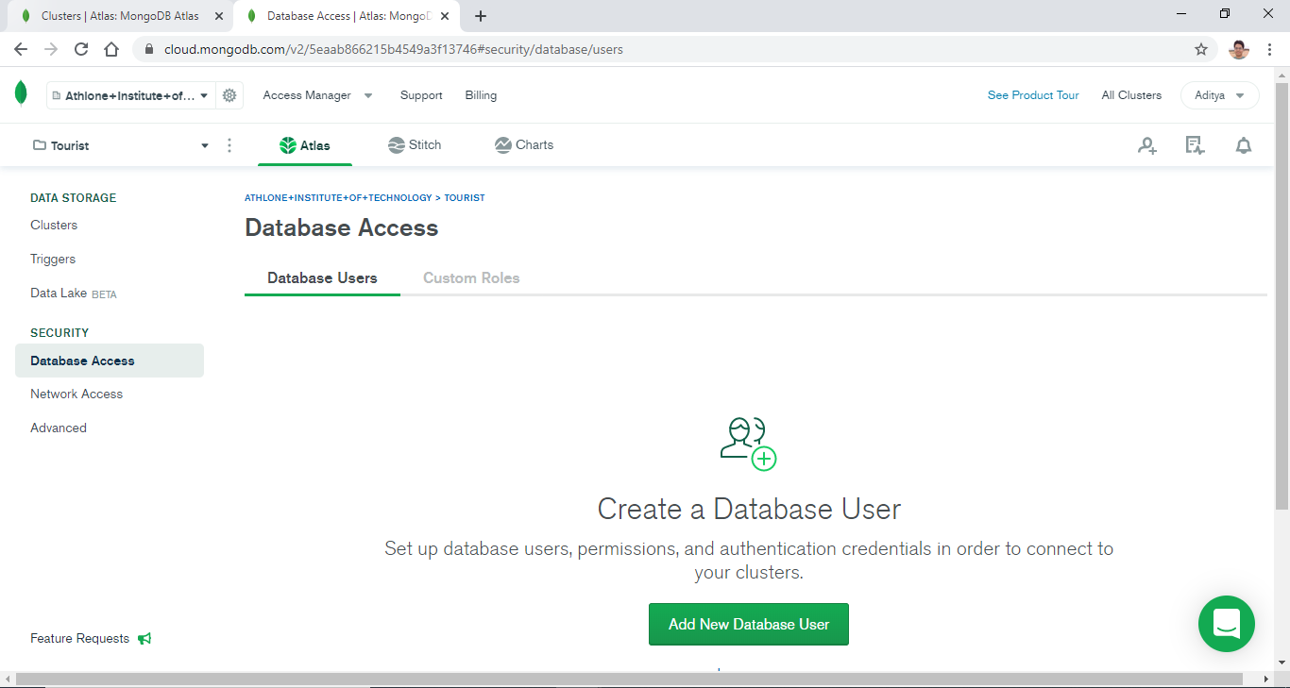

Figure 15: Add new database user

1. Select *Password* as the authentication method and provide suitable username and password for the database user. Select *Read and write to any database* option under the database user privileges and click on *Add User*.

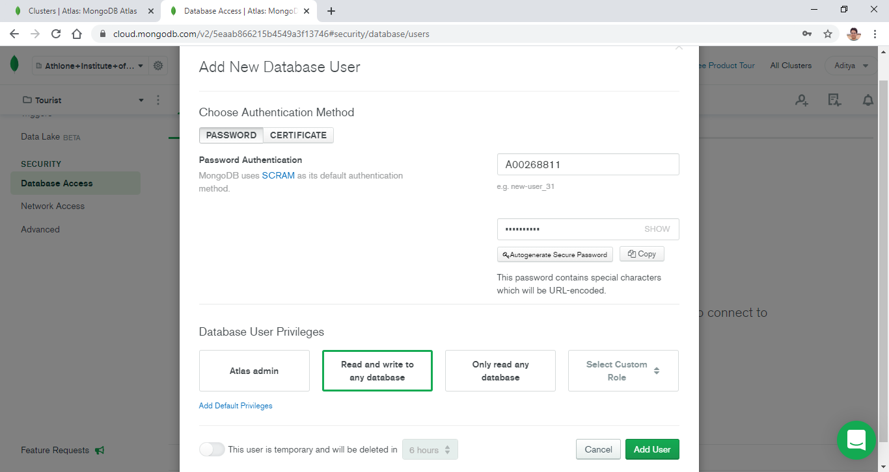

Figure 16: New database user settings

1. The database user, once successfully deployed, is ready to access the Sandbox cluster.

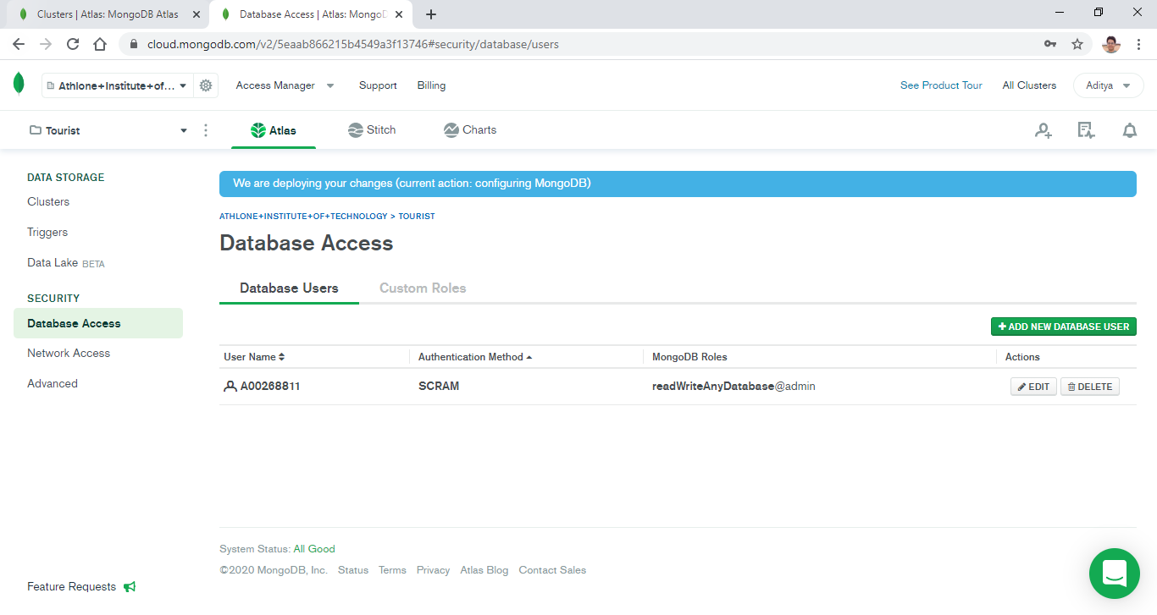

Figure 17: Successfully deployed database user

1. Switch back to the cluster overview page and click on *Connect* as shown below.

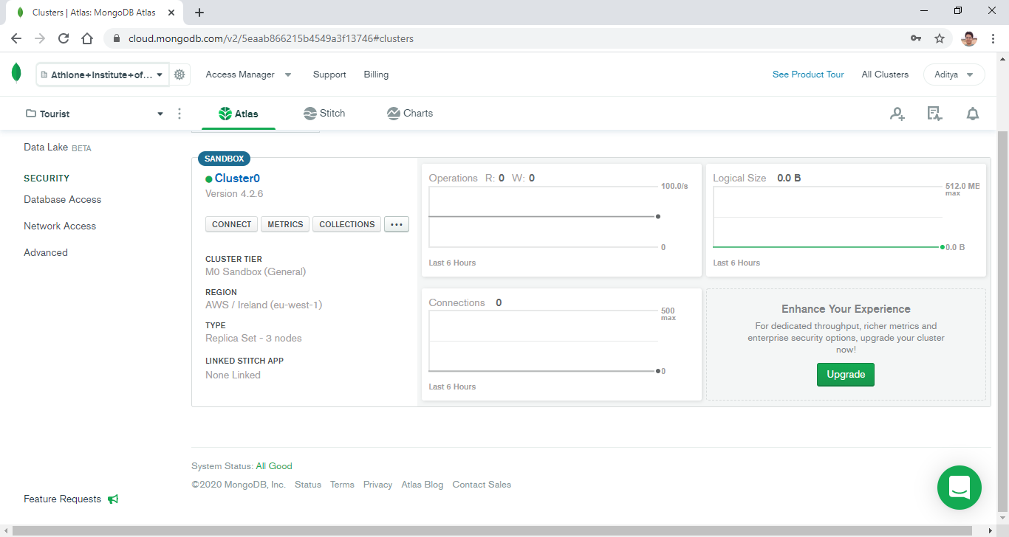

Figure 18: Cluster overview

1. The cluster can be connected with various applications such as mongo shell, MongoDB Compass or any other application that uses MongoDB native drivers.

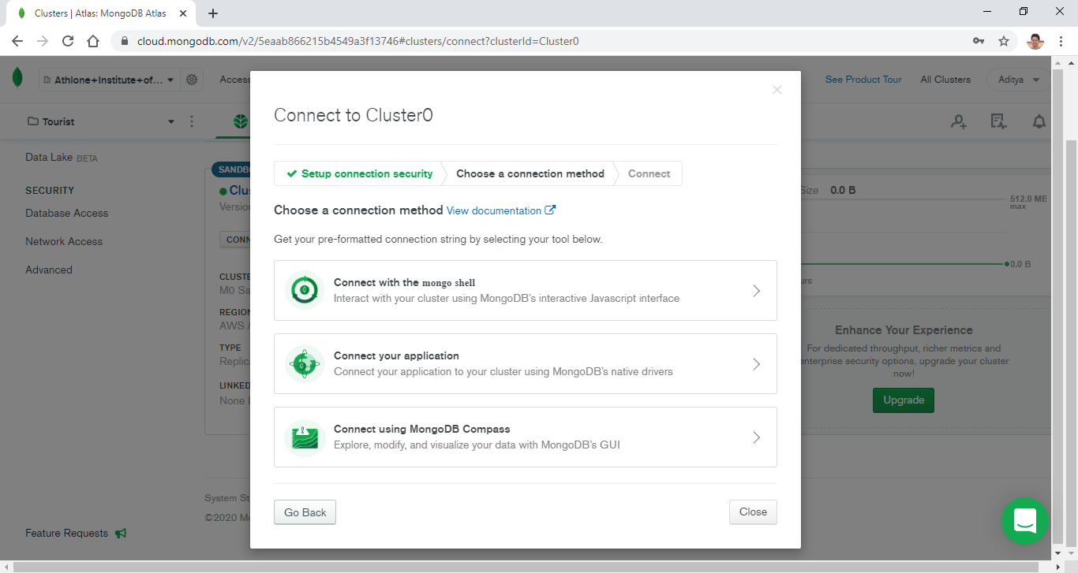

Figure 19: Applications that can be connected to the Sandbox cluster

1. Connect the Sandbox cluster to MongoDB Compass by clicking in *Connect using MongoDB Compass* option then select ‘*I have MongoDB Compass’* (if already installed) to get the connection string.

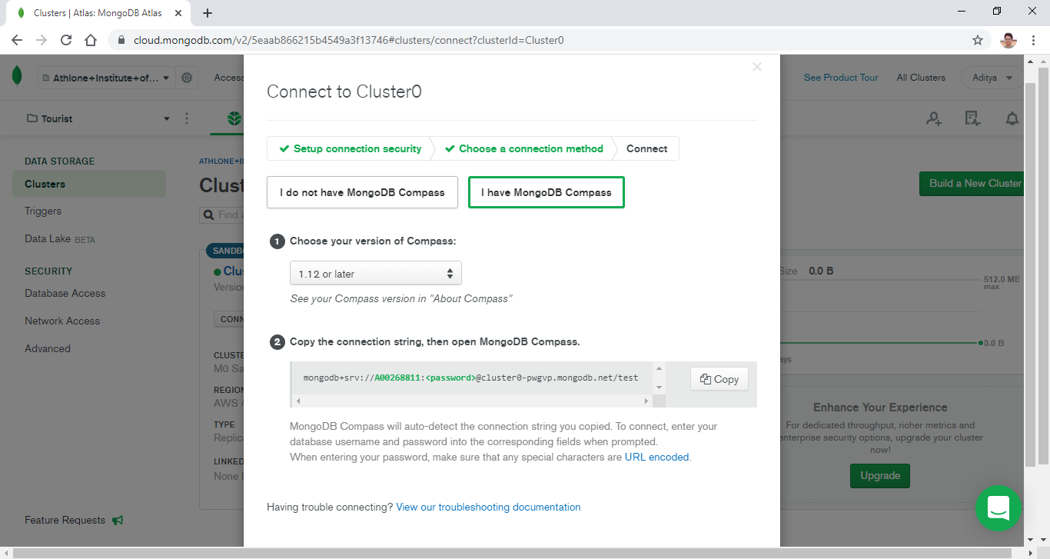

Figure 20: Connection string to connect MongoDB Cluster to Sandbox cluster

1. Copy the connection string and go to Compass and paste the connection string in the *New Connection* option. Replace <password> with the actual password for the database user entered during step 16 and click on *Connect*.

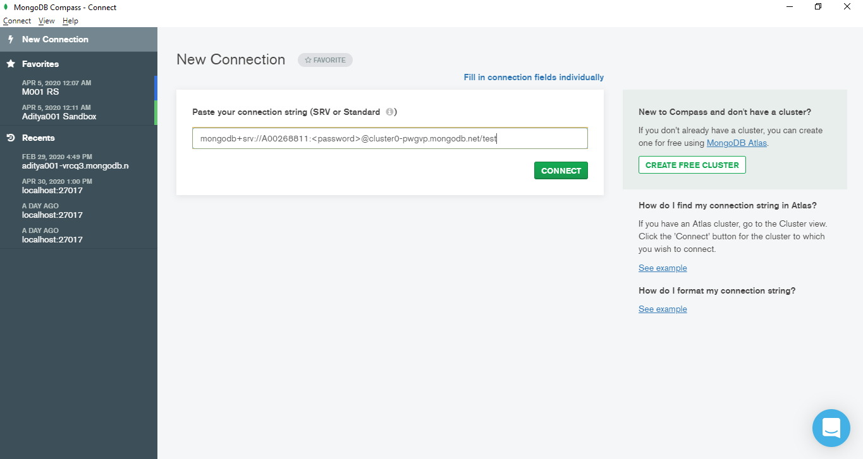

Figure 21: Connect MongoDB Cluster to Sandbox cluster using the connection string

1. Now the Compass is connected to the Sandbox cluster and the databases in the cluster are visible. To create a new database in the cluster, click on *Create Database*.

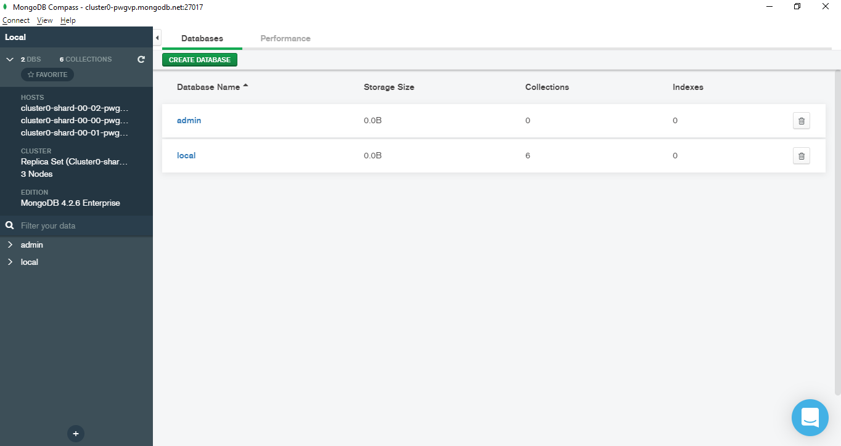

Figure 22: View databases in cluster using Compass

1. Enter the desired database name and collection name and click on *Create Database*.

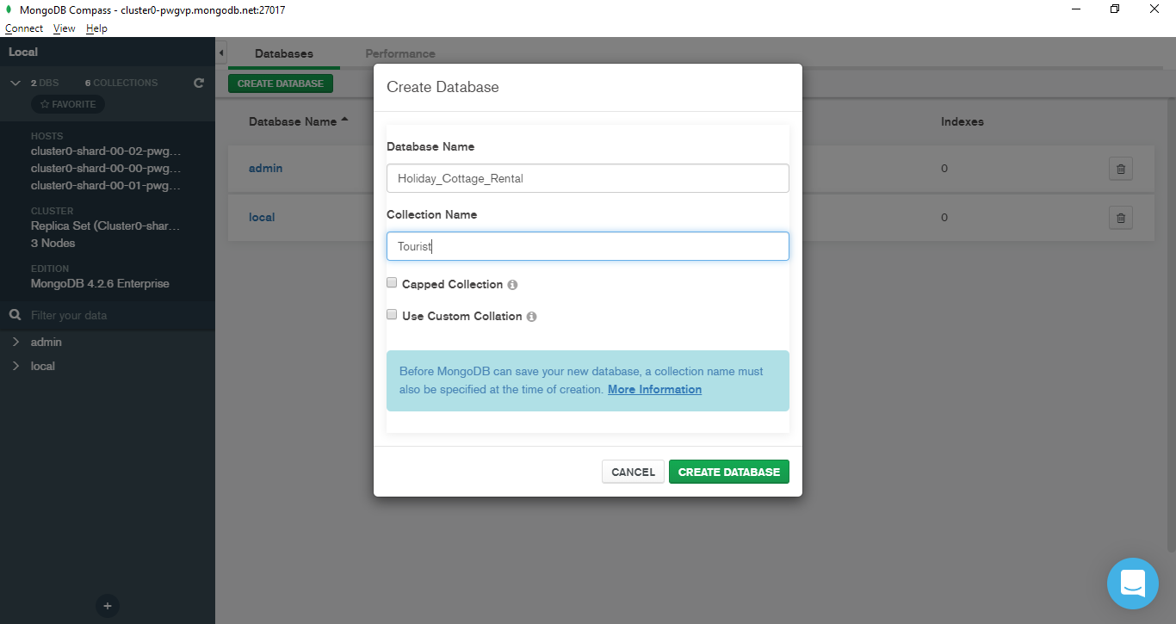

Figure 23: Database and collection creation through MongoDB Compass

1. The newly created database is now visible after refreshing the databases tab. Click on the *Holiday_Cottage_Rental* database to view the collections inside the database.

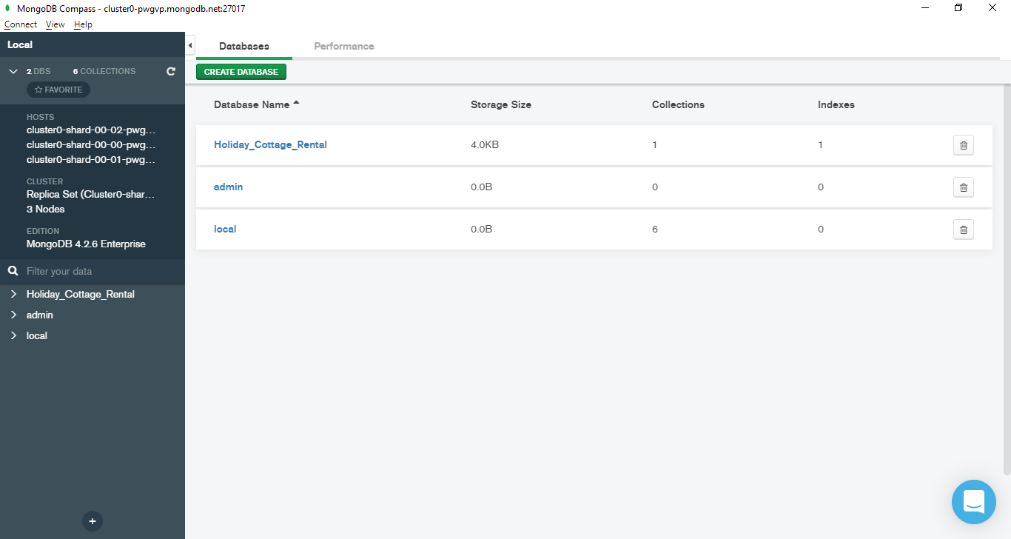

Figure 24: The new database is created

1. The collection named Tourist is visible within the database. Click on the collection to see the documents inside the collection (Note that we have not added any document in this collection yet).

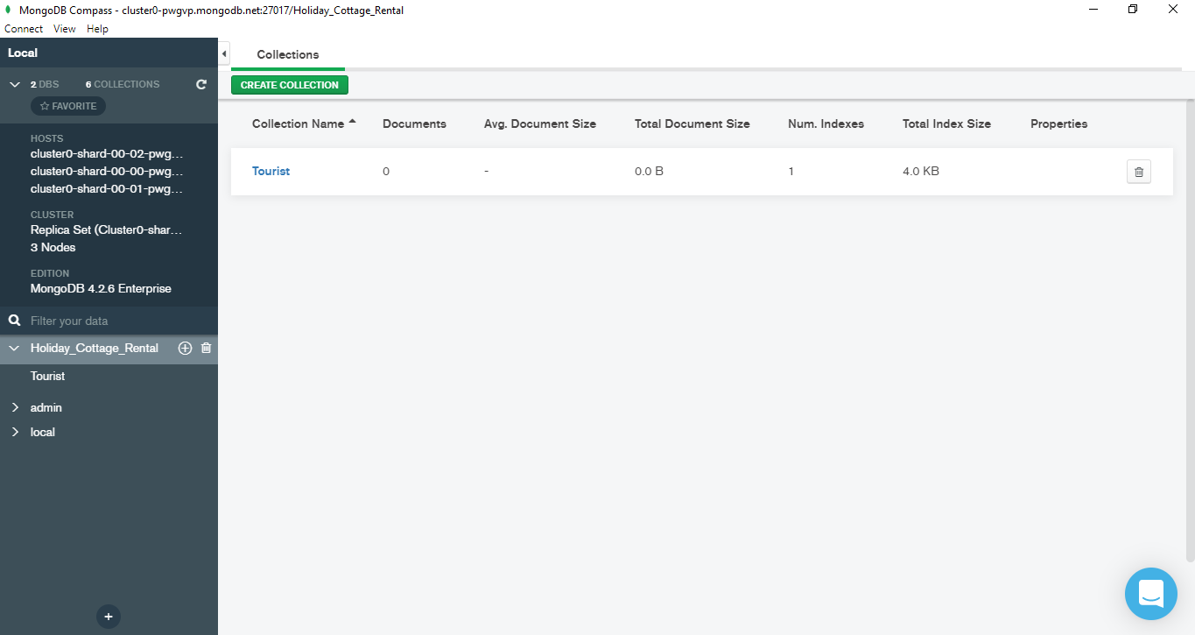

Figure 25: Collection inside the newly created database

1. The collection is empty since no documents are inserted yet. To import the data from a JSON or CSV file, click on *Import Data*.

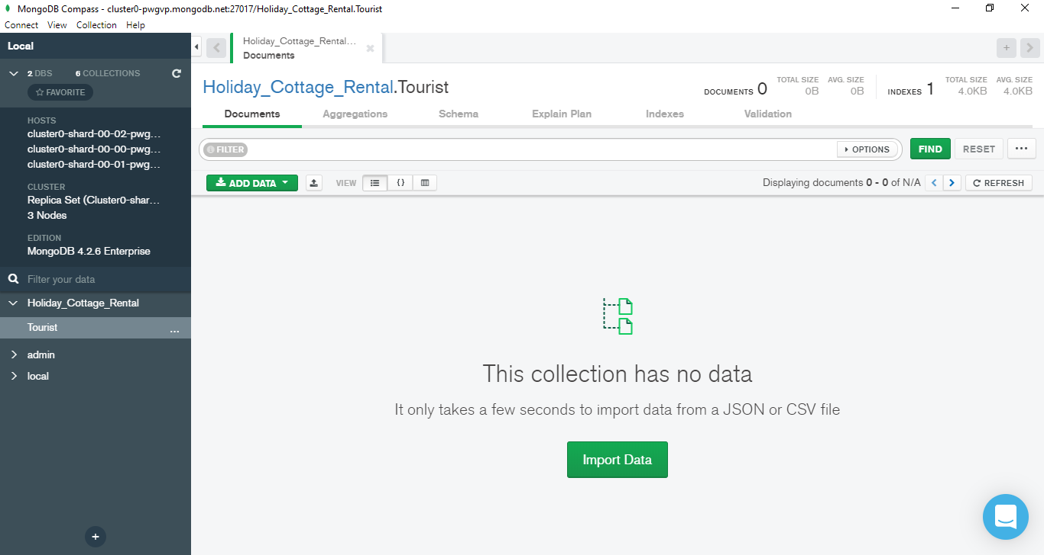

Figure 26: Importing data into the collection

1. Browse the JSON or CSV file and click *Import*.

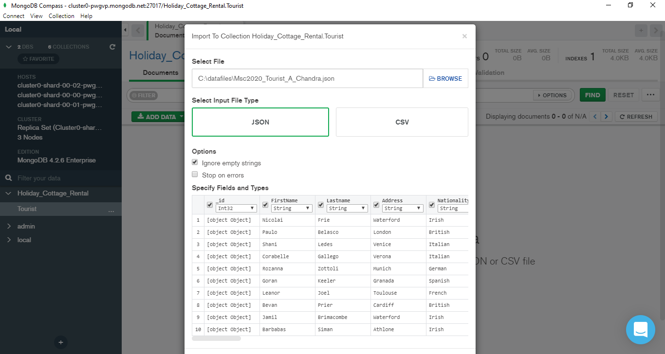

Figure 27: Importing data from JSON file

1. Another method to insert documents into the collection is through Insert Document option under the *Add Data* button as shown below. Using this option, we can copy and paste the contents of the JSON file to load the data.

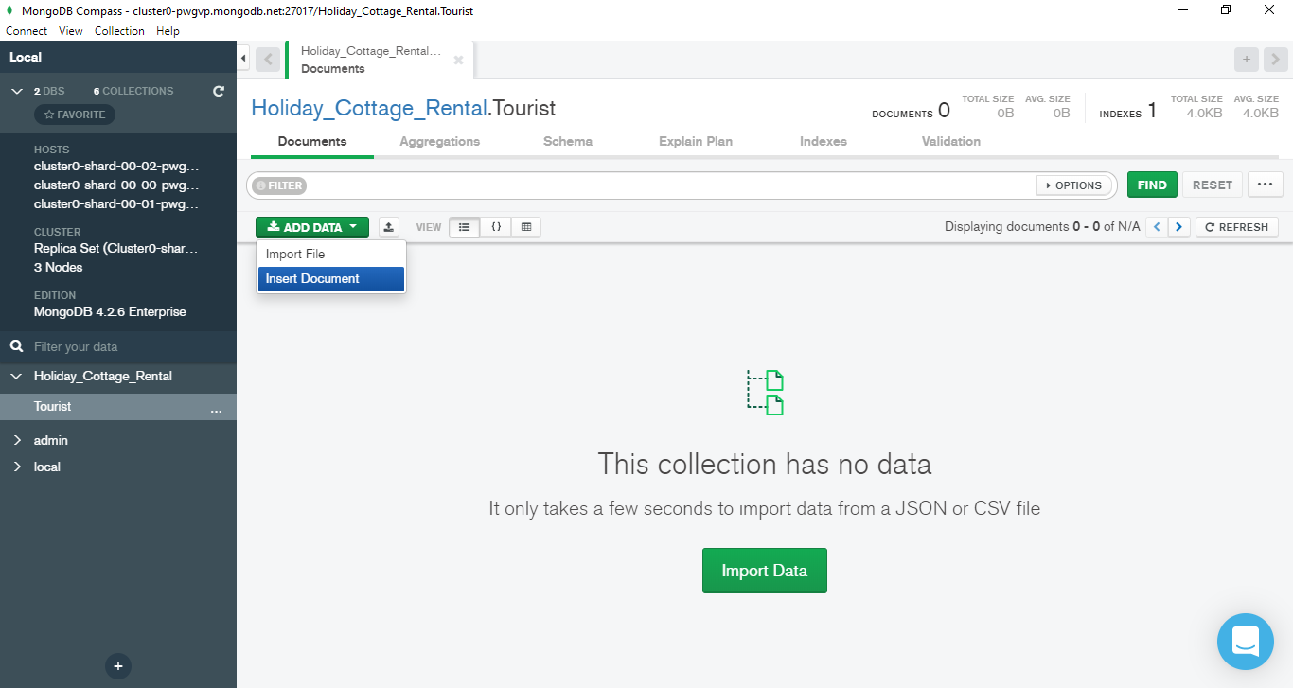

Figure 28: Adding data to collection using Insert Document option

1. Copy the contents of the JSON file and paste in the space provided then click on *Insert*.

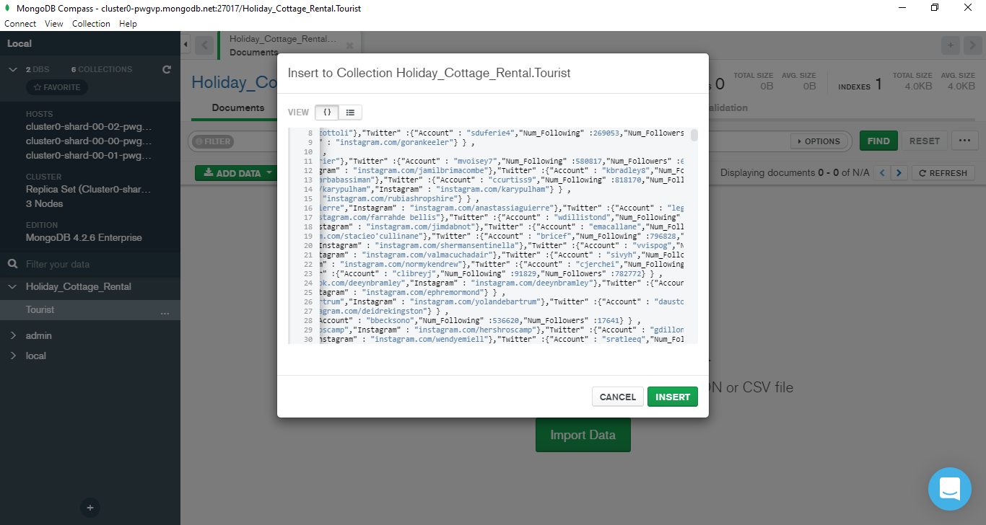

Figure 29: Insert documents by manually copy pasting the JSON formatted documents

1. The documents are now inserted inside the Tourist collection.

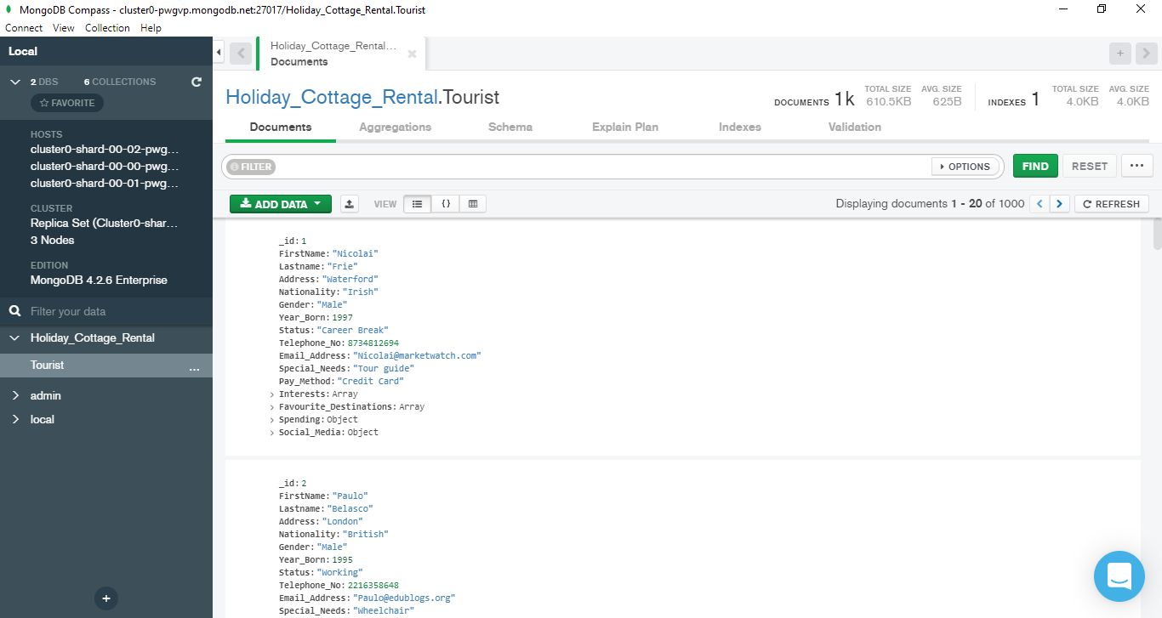

Figure 30: Successfully inserted documents within Tourist collection

1. To view the inserted documents in MongoDB Atlas, go to Atlas and click on *Collections*.

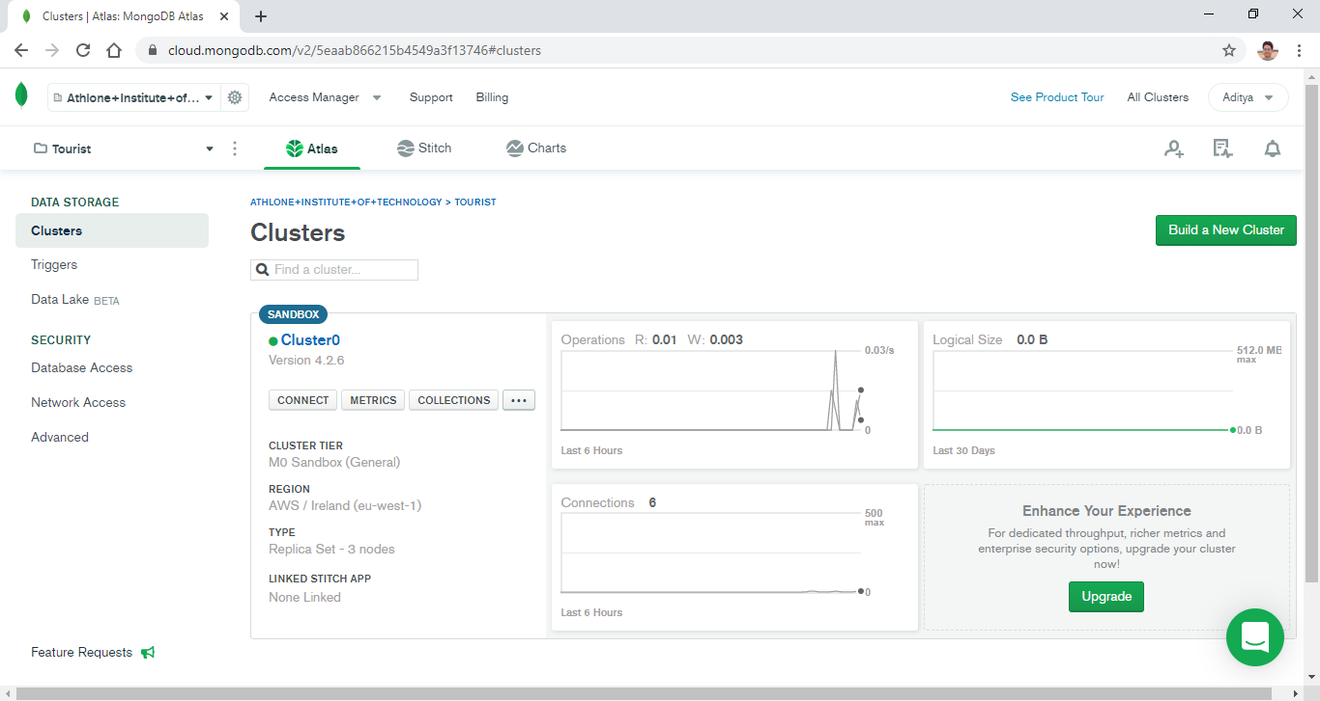

Figure 31: Check inserted documents through MongoDB Atlas

1. The documents within Tourist collection are now visible in the Atlas as well and in this page, we can also write simple queries on the documents to filter out documents based on our requirements.

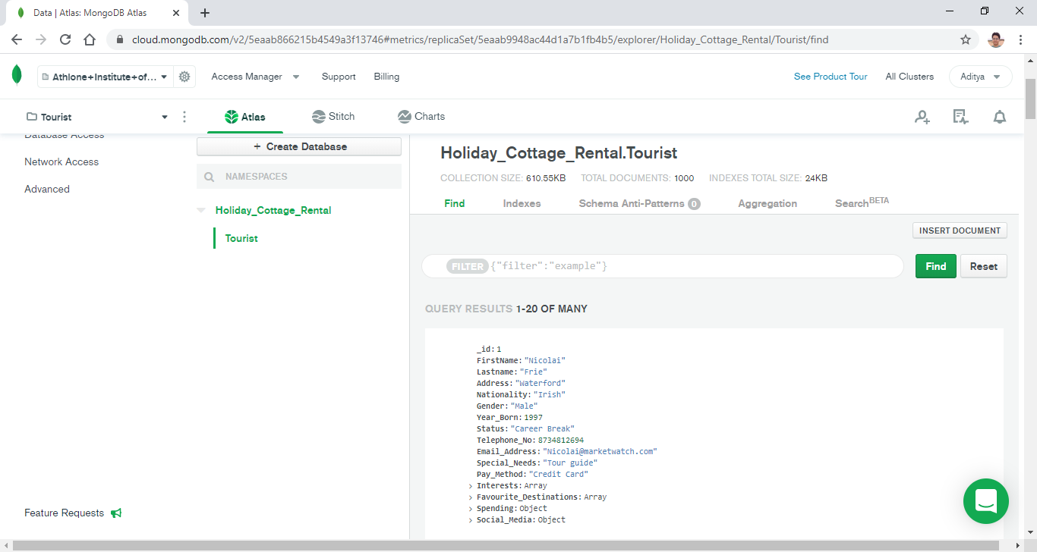

Figure 32: Documents within MongoDB Atlas

# MongoDB Atlas – Simple Query

1. **Display the details of male French tourists who need tour guide and have interest in at least hiking and cycling.**

Filter -

{Nationality:"French", Gender:"Male", Special_Needs:"Tour guide", Interests: {$all:["Hiking","Cycling"]}}

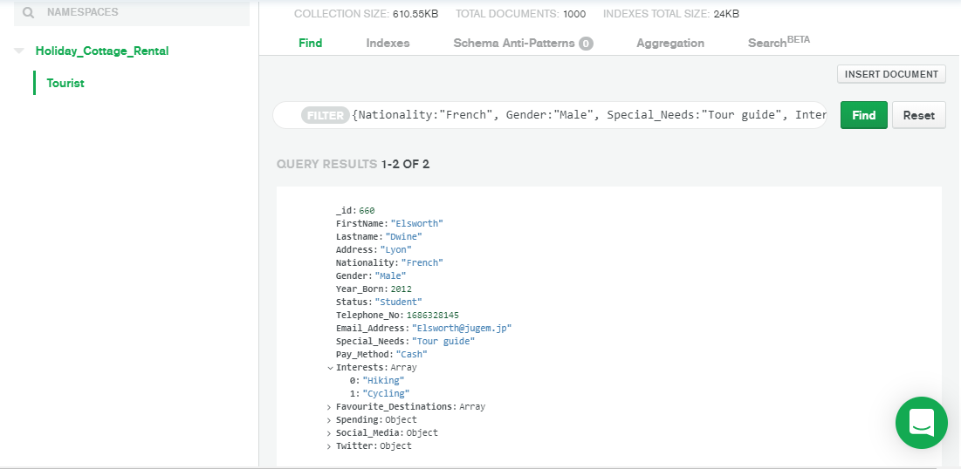

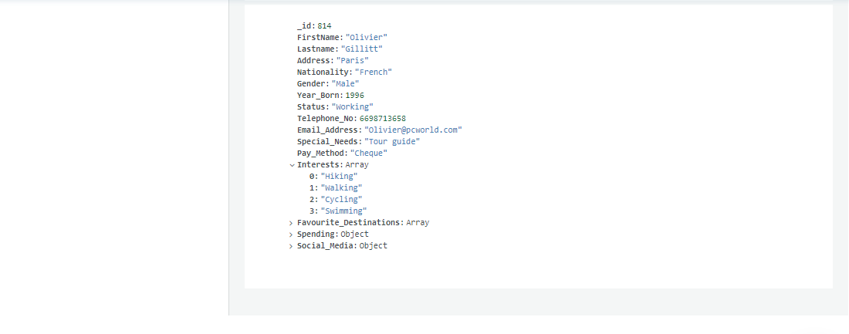

# MongoDB Atlas – Aggregation Framework

1. **For different counts of interests, display the number of tourists having that number of interests and the average spending for that count of interests. Sort the result in decreasing order of interests count.** **(For query explanation, refer to question number 3 of MongoDB Shell – Aggregation Framework)**

$group –

{

_id: {

countInterests: {$size: "$Interests"}

},

num_tourists: {

$sum:1

},

avg_spending: {

$avg: {

$sum: [

"$Spending.Travel",

"$Spending.Accommodation",

"$Spending.Food"

]

}

}

}

$sort –

{

"_id.countInterests": -1

}

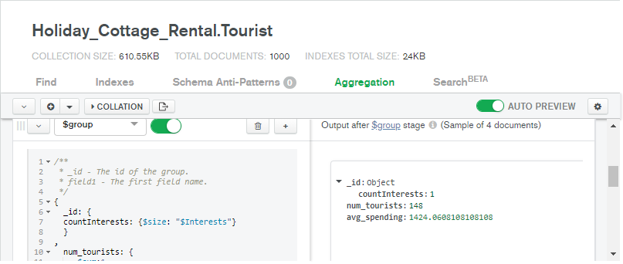

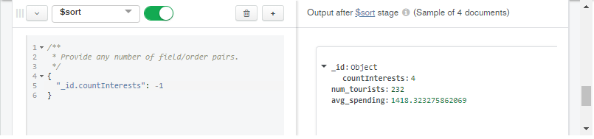

# MongoDB Compass and Atlas – Other Features Explored

## Schema

The *Schema* tab allows the users to see the data type of the fields in the documents and their shape. It also provides an interactive visualization of the data in each field and hovering the mouse pointer on the graph reveals additional information about it such as the proportion of different categories in the overall collection.

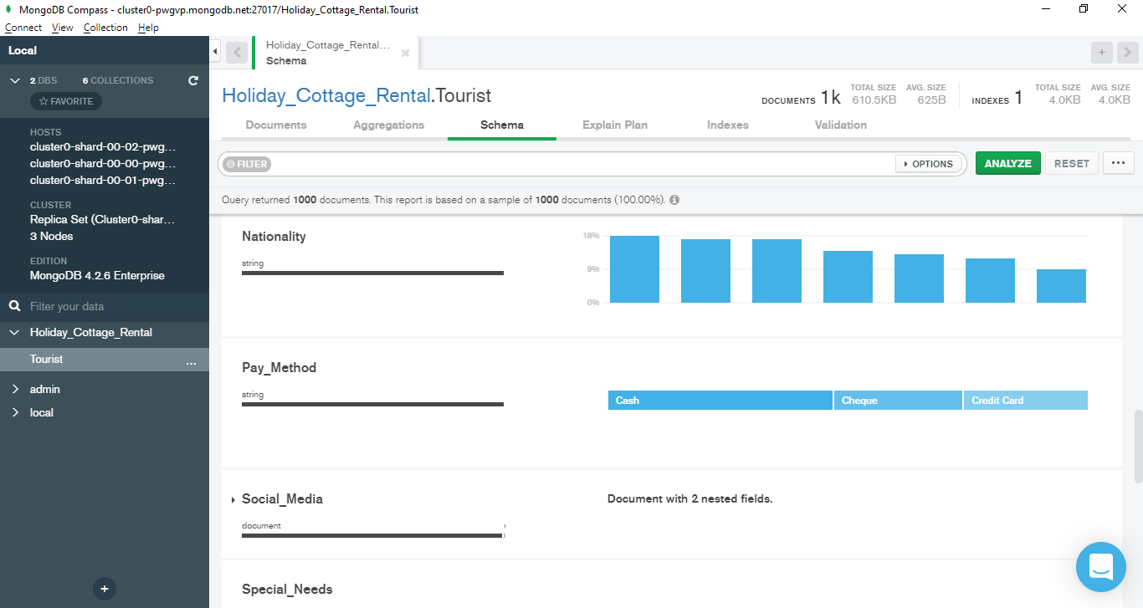

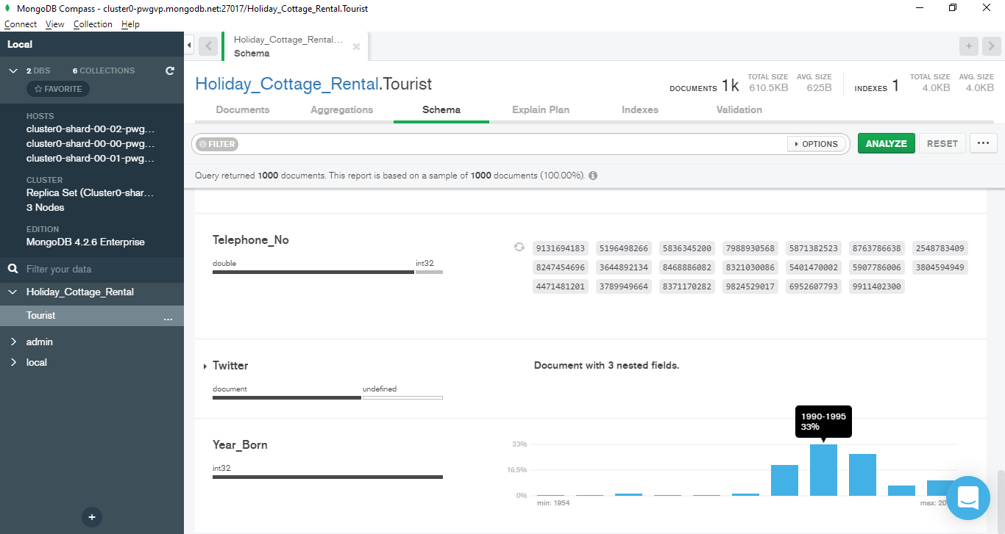

## Edit document

MongoDB Compass provides the option to edit the document directly from the *Documents* tab which makes it very convenient to make modifications in the document without the need of an update query. The user can easily change the values in the fields or change the data type of the fields or delete a field from a document without hassle.

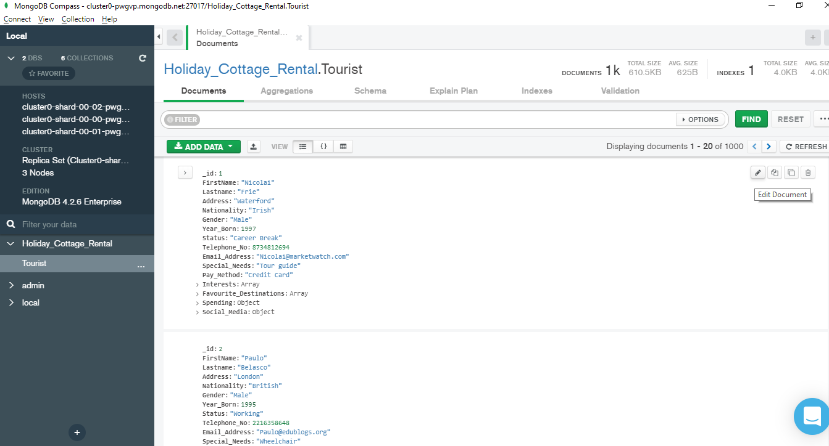

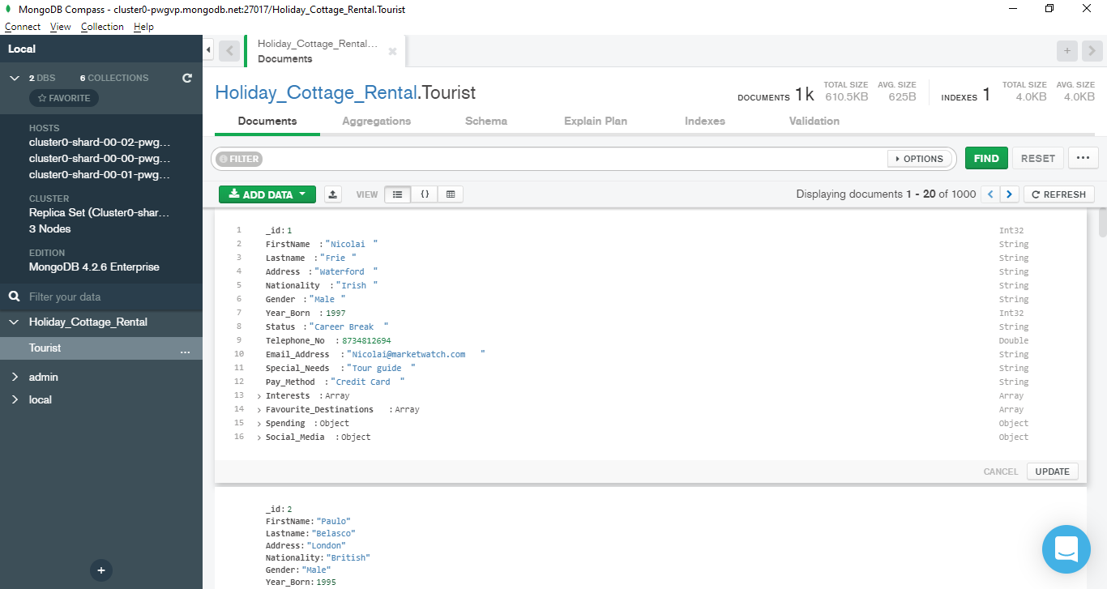

## Activity History

MongoDB Atlas allows the users to check the history of activities carried out on the cluster by the users which is crucial if there are multiple users accessing the cluster. It displays the details of performed activity along with collection name, username and host id with date and time of the activity.

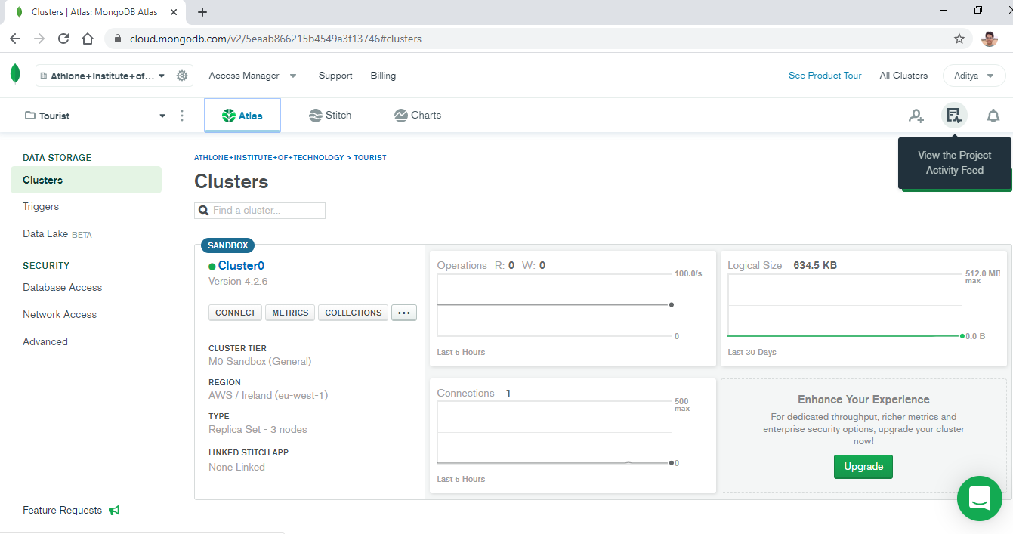

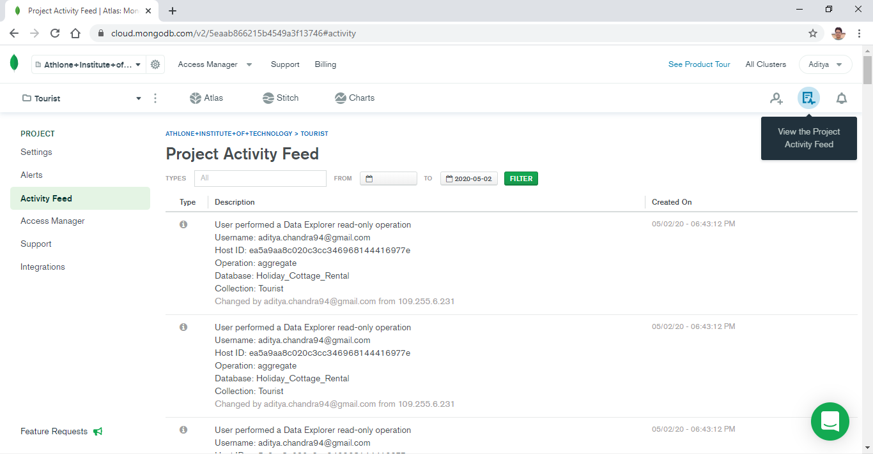

# Appendix

## Links to YouTube Screencasts

1. Aggregation Framework Example in MongoDB Shell ($match, $facet) <https://www.youtube.com/watch?v=DGl91aF0zTQ>
2. Aggregation Framework Example in MongoDB Compass ($match, $unwind, $group, $sort) <https://www.youtube.com/watch?v=WOAMrDlLXpQ>

## Links to Referred Websites

1. MongoDB Documentation (n.d.). *Query an Array.* Available at: <https://docs.mongodb.com/manual/tutorial/query-arrays/> [Accessed: 29 February 2020]
2. MongoDB Documentation (n.d.). *Query on Embedded/Nested Documents*. Available at: <https://docs.mongodb.com/manual/tutorial/query-embedded-documents/> [Accessed: 4 April 2020]
3. MongoDB Documentation (n.d.). *Query and Projection Operators.* Available at: <https://docs.mongodb.com/manual/reference/operator/query/#query-selecto> [Accessed: 29 February 2020]
4. MongoDB Documentation (n.d.). *$regex*. Available at: <https://docs.mongodb.com/manual/reference/operator/query/regex/index.html> [Accessed: 4 April 2020]
5. MongoDB Documentation (n.d.). *Aggregation Pipeline Stages.* Available at: <https://docs.mongodb.com/manual/reference/operator/aggregation-pipeline/> [Accessed: 12 April 2020]
6. MongoDB Documentation (n.d.). *Aggregation Pipeline Operators*. Available at: <https://docs.mongodb.com/manual/reference/operator/aggregation/> [Accessed: 12 April 2020]
7. MongoDB Documentation (n.d.). *MongoDB Compass*. Available at: <https://www.mongodb.com/products/compass> [Accessed: 22 February 2020]
8. Ashiq KS (2019). *Aggregation in MongoDB.* Available at: <https://medium.com/@ashiqgiga07/aggregation-in-mongodb-209515e5b0ba> [Accessed: 17 April 2020]